

Us

er



Documentation



*Hela Weda Piyasa Ayurwedic Hospital*



Team Software Project



Group 08



Level - 3



Department of Computer Science



Faculty of Science



University of Jaffna



# Contents

**Executive Summary ------------------------------------------------------- 3**

**Team information ----------------------------------------------------------- 7**

**Software License ----------------------------------------------------------- 7**

**Graphical User Interface ------------------------------------------------- 8**

**Registration -------------------------------------------------------- 8**

**Reset Password -------------------------------------------------- 8**

**Login ----------------------------------------------------------------- 9**

**Admin’s UI --------------------------------------------------------- 10**

**Doctor’s UI --------------------------------------------------------- 14**

**Patient’s UI --------------------------------------------------------- 24**

**Pharmacist’s UI --------------------------------------------------- 33**

**Medicine Producer’s UI ---------------------------------------- 42**

**Ingredient Supplier’s UI ---------------------------------------- 50**

# Executive Summary

##  Outcome to be achieved

At present, there are lots of private hospitals are available to provide medical services. People are seeking private hospitals as they believe that the private hospitals are providing higher quality treatment than government hospitals. This is the online system that can bring more advantages for the doctors, patients etc.

##  Users

There are mainly 5 users. They are Patient, Doctors, Pharmacist, Medicine Producers, Ingredient suppliers. Additionally, there is an admin also available to control some particular activities.

##  Problem Statement

* **Patients**

* + Nowadays, if a patient wants to see a doctor, they should book before. So they need to visit to hospital and book.
  + If they want to buy medicines they need to go to that pharmacy.
  + There is no way to send their current condition to corresponding doctors.
  + Now, we have clinic books to see past histories. In case, if the book is missed, no way to get back

.

* **Doctors**

* + Normally, doctors write prescription in papers. So patient should carry the paper to pharmacist.
  + To keep admitted patient record we need to maintain a big ledger book.
  + Doctors want to update the admitted patient records to give medicines to them.
  + If doctor will be late or unable to come, he should inform to the staffs.
  + Doctor doesn’t aware himself how many patients are going to come today.

* **Pharmacist**

* + Pharmacist is not aware of medicine stocks. When will be expired? , how many stocks are there?
  + Pharmacist should ask with patient the prescription or medicine details and he need to calculate the bill.
  + Pharmacists are unaware about the amount of medicines and expiry date of medicines available in the stock.

* **Medicine Producer**

* + He should maintain a medicine table manually.
  + He should maintain ingredient table manually.
  + If he creates a new medicine he should acknowledge to pharmacists.
  + When ingredients finish in stock he will say to suppliers.
  + He may be forgotten to issue order. So he should maintain orders table manually also which is from pharmacist.

* **Ingredient Suppliers**

* + He should manage what ingredients stock has and maintain orders from producers.

##  Solution

* **Patients**

* + Patients can simply book a doctor and order medicines from anywhere rather than go directly to the hospital.
  + They can send their symptoms, as text, images even as audio file.
  + No need to check any clinic books to see what the doctor said in last meeting.

* **Doctors**

* Doctors can pass the prescription to pharmacist via online.
* Patients can be admitted at hospital via/through this system.
* Daily updates also can be added through system.
* Doctors can see patients’ symptoms through this system and they can suggest the solution.
* Simply they can watch how many appointments they have today.
* They can update the availability time.

* **Pharmacists**

* + Pharmacists are going to aware of medical stock through this system.
  + They don’t need to calculate the bill amount. System will do.
  + They can see the requested orders from patients and doctors.
  + They can order medicines via online to medicine producer.

* **Medicine Producer**

* + Medicine and ingredient table will be maintained in their database.
  + He can able to acknowledge to pharmacist, when pharmacist requires new medicine.
  + Orders from pharmacist will be maintained.
  + Producer can place order to supplier when ingredients are finished.

* **Ingredient Supplier**

* + Supplier can manage his ingredient stocks and can see the ingredients order details from medicine producer.

**Usecase Diagram**

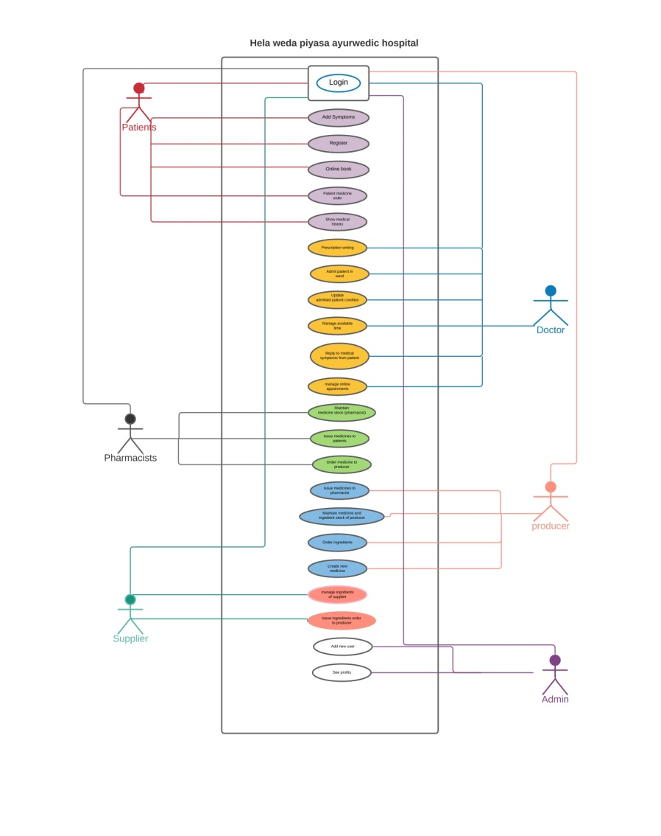

# Team Information

This web system is developed by the following team members.

1. Elackshana M. - elackshana@gmail.com 2017CSC018(Database Design)
2. P.A.Gamage. - ajanthasirigamage@gmail.com 2017CSC033(App Development)
3. Dilki Hasara - dhwways@gmail.com 2017CSC022(UI Design)
4. S. Lokavannilavan - lokavan007@gmail.com 2017CSC047(System Testing)
5. ULM Afrid - mafrid029@gmail.com 2017CSC029 (Team Leader)

Blog link: [Click Here](https://umafd.blogspot.com/2021/04/hela-weda-piyasa-ayurwedic-hospital.html)

Customer: Mrs. Mala Gunawardhane, Hulandawa, Monaragala.

Mentor: Ms. Samantha Tharani Jayakumar.

# Software License

We are using following softwares.

* PHP – version 7.4.10
* Laravel – version 4.1.1
* Composer – version 1.10.13
* Apache – version 2.0
* Microsoft Visual Studio Code – version 1.52.1
* Mysql – version 10.4.14

**Graphical User Interface**

**Registration**

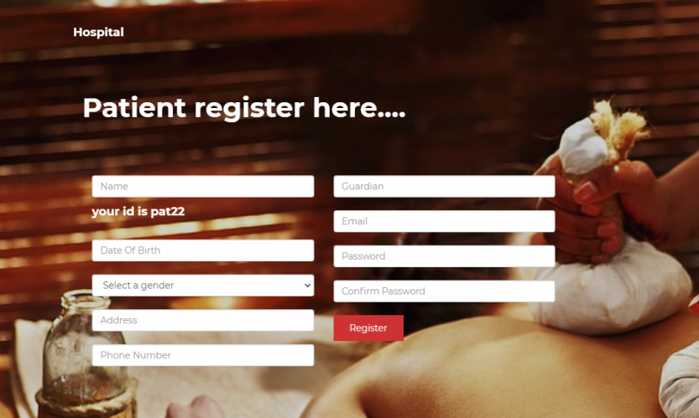

* Patients can register themselves here.
* They should fill all fields here. Otherwise they cannot register. It will be showing message.
  + If they don’t fill phone number filed, then it will show “**Phone Number is empty”.**
* The patient id will be given while they registering. So they can use it for login to system.
* Other users can be only registered by admin.

**Reset Password**



* If a user forgot his password he can reset by providing user id and his corresponding mail that he gave already in his profile.
* A new password will be generated and sent to his mail by system.

### **Login**



* A login page is a web page or an entry page to a website that requires user identification and authentication, regularly performed by entering a username and password combination. Logins may provide access to an entire site or part of a website.

* All users must register for this service before availing it. A user can enter this website by entering the password related to the name he will receive during registration.



* User’s information, contact details and address are here.

**Test Cases**

* If the user enters a valid user name or password, then he can enter the system.
* If he enter an invalid user name or password, then it will indicate a message “wrong password or username”

### Admin’s UI

The UI of admin has 3 features.

1. **Home**
2. **Registration**
3. **Report**

#### **Home**



* In this page the user (admin) can insert or edit his details using the ‘Edit Profile’ button.
* If user clicks the ‘**Edit Profile’** button, it will show a form. He can add or update his details on this.

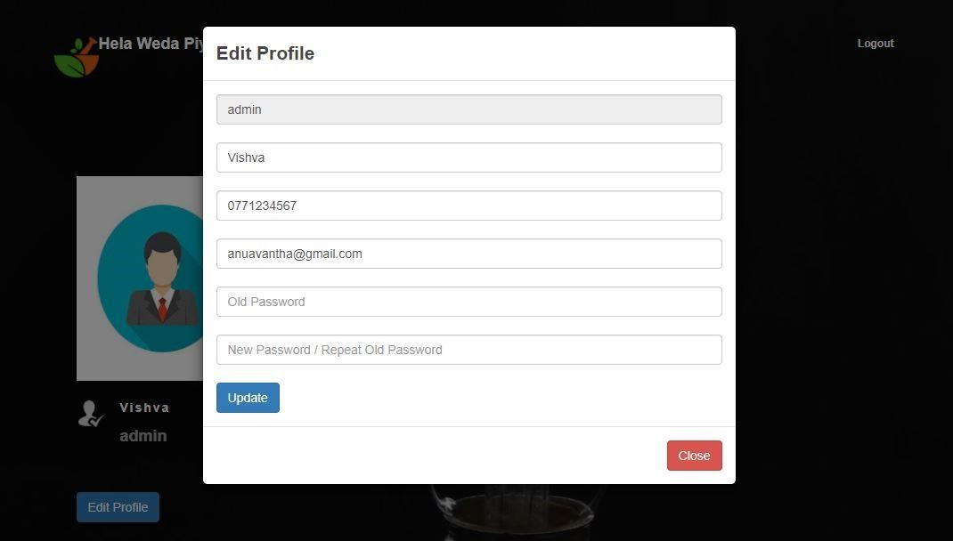

* In this form user should fill his name, phone number, email, old password and new password.
* If he fails to fill, it will show an error message.
  + E.g. Phone number is required, email is required.
* If the old password is wrong it’ll show, “Old **password is wrong** “.

1. [**Registration**](http://127.0.0.1:8000/medicalstock/pha1)

* This page is used to maintain all user details and also register new users by admin.

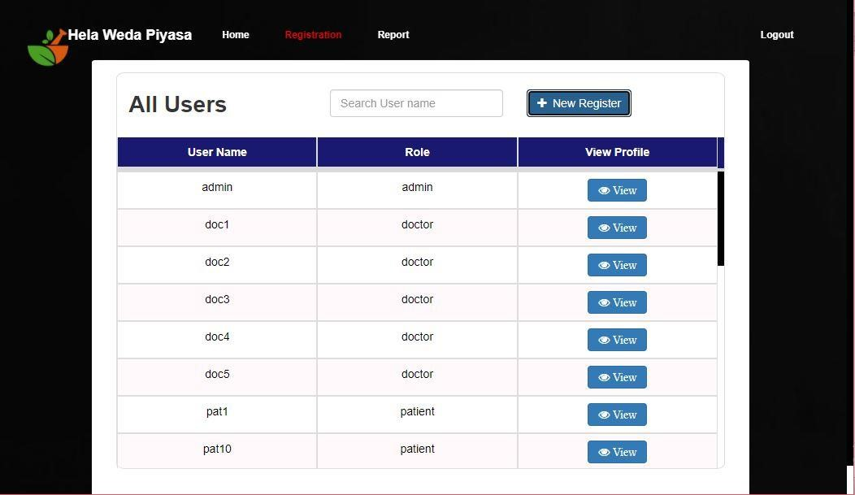

* ‘**View’** button is used to view the user profile.



* ‘**New** **Register’** button used to register new users and add their details.

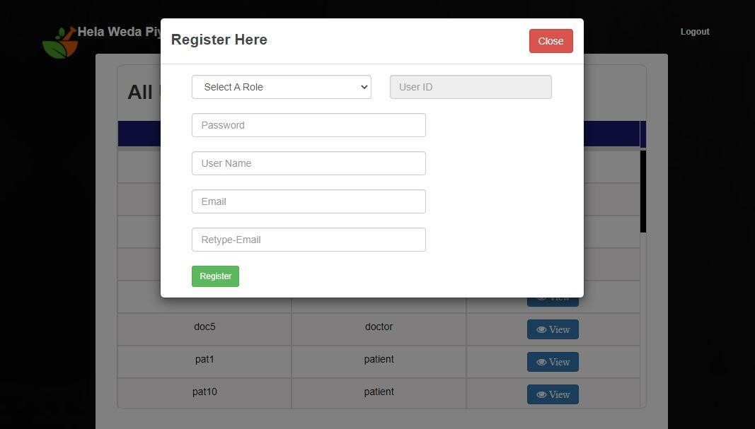

* User ID is created automatically when admin selects the role. The other fields must be filled otherwise it’ll show error messages.
* To register a new user, admin should connect to the internet, otherwise it will show an error message. “**Check** **your** **internet** **connection**”.

#### **Report**

* This page is used to view the profit details.

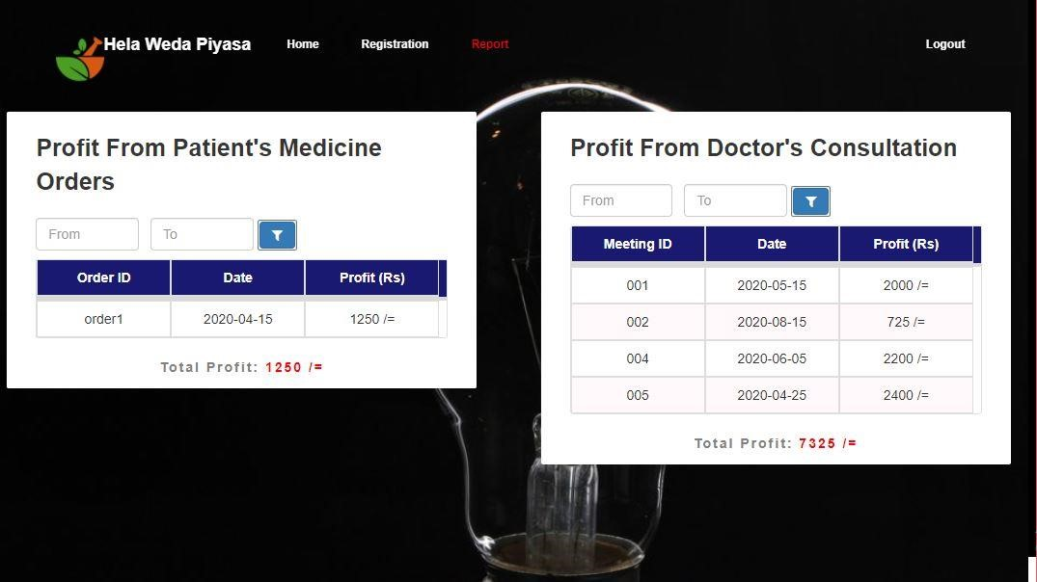

* Admin can find the profit by filtering the date. And he can also find the total profit below the table.

## DOCTOR’S UI

The UI of doctor has 7 features.

1. **Home**
2. **Prescriptions**
3. **Admitted Patient Details**
4. **Admitted Patient**
5. **Available Time**
6. **Medical Symptoms**
7. **Appointments**

### **Home**



* In this page the doctor can insert or edit his/her details using the ‘**Edit** **Profile’** button. And He can add/change the profile picture.
* If doctor click the Edit Profile button, it will show a form. He can add or update our details on this.

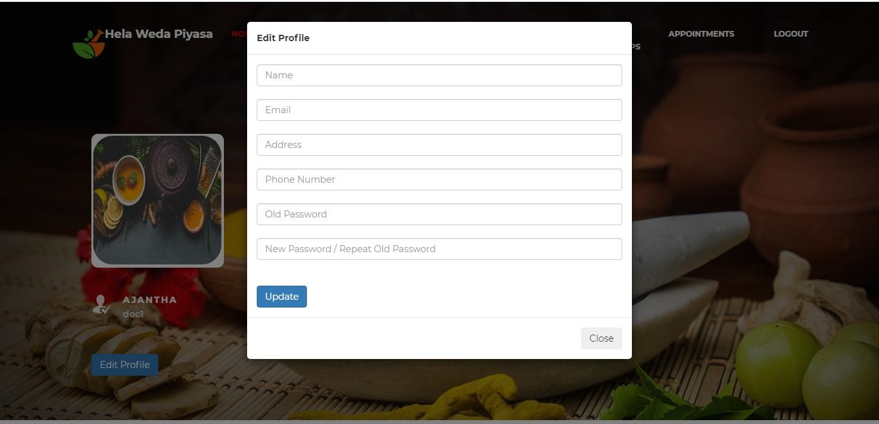

* Here doctor should fill name, address, phone number, old password and new password. He can avoid email to fill the form.
* If doctor fill it with valid data, it will show a message. “**Updated** **successfully**”
* If he fails to fill, it will show an error message.
  + E.g. “Address is empty”, “New Password is empty”
* If the old password is wrong it will show, “**Password** **is** **wrong**”

### **Prescriptions**

* On this page doctor can see the patient's past medical records and each patient’s details.

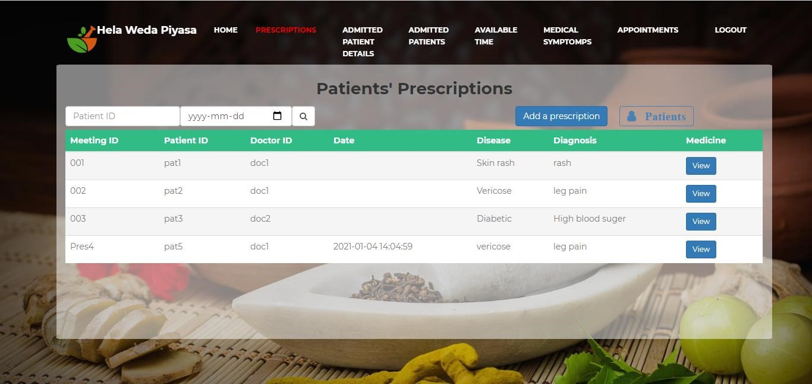

* For example, the patient's registration number, as well as who diagnosed the disease and the medication given to him. This information is represented to the doctor by a table.
* If the doctor clicks “**Add** **a** **prescription**” button, it will show a form. He can add a prescription on this.

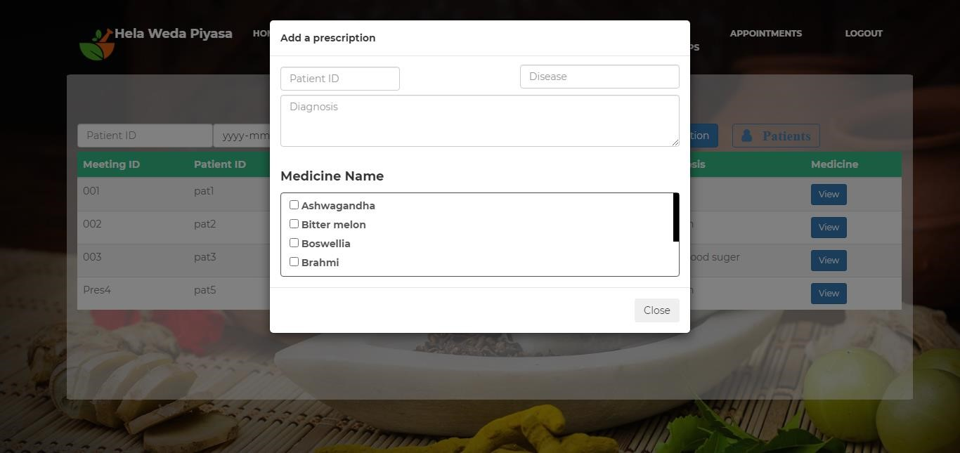

* Here the doctor should fill Patient’s id, Disease, Diagnosis and Medicine Name.
* If he inserts all data, it will show a message, “**Added** **successfully**”
  + If he fails to fill, it will show an error message, “**The** **patient** **doesn’t** **exit**”
* If he searches valid patient’s ID or date, the table will show the relevant details.
  + If he searches invalid patient’s ID or date, the table will show a message, “**No** **prescriptions** **found**”
* If the doctor click “**Patients**” button, it will show patient’s details

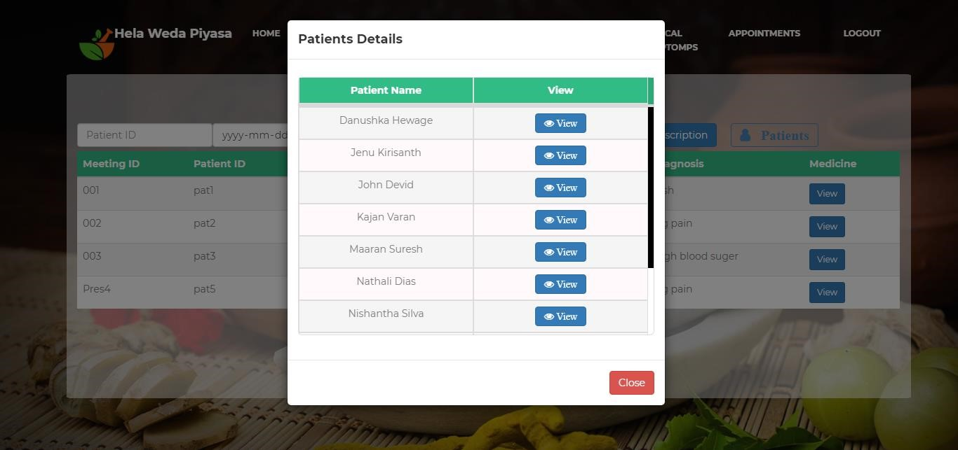

* When he clicks the ‘**View’** button, then he can see the relevant patient details.

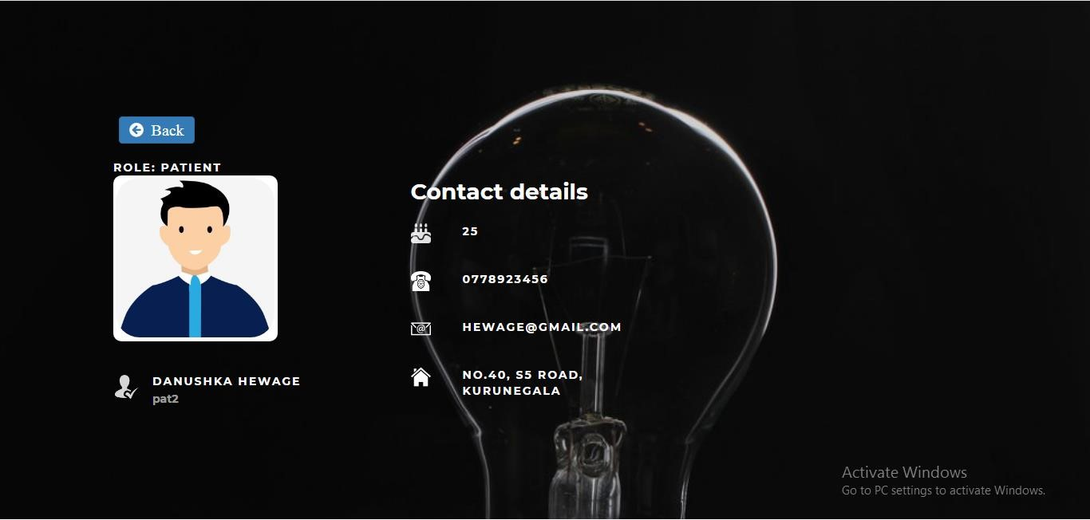

* When the doctor click “**Back**” button, he can go previous page.

### **Admitted Patient Details**

* This page includes all the details of the patient when they see the doctor and when the patient is admitted to the hospital after the doctor's diagnosis.

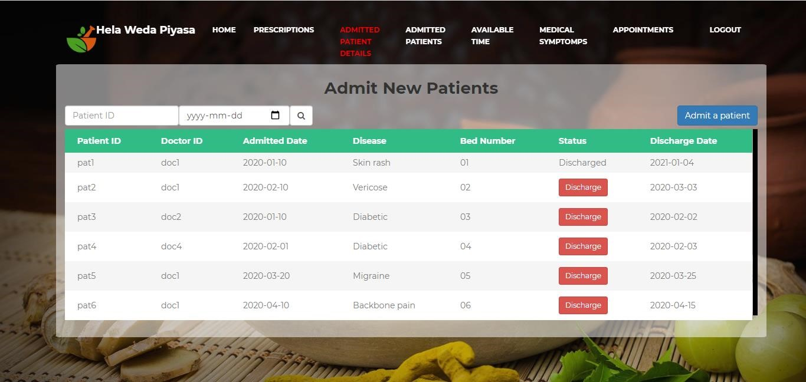

* For example, the patient's registration number and the bed number where he was hospitalized.
* If he clicks the “**Admit** **a** **patient**” button, it will show a form. He can add Patient’s details on this.

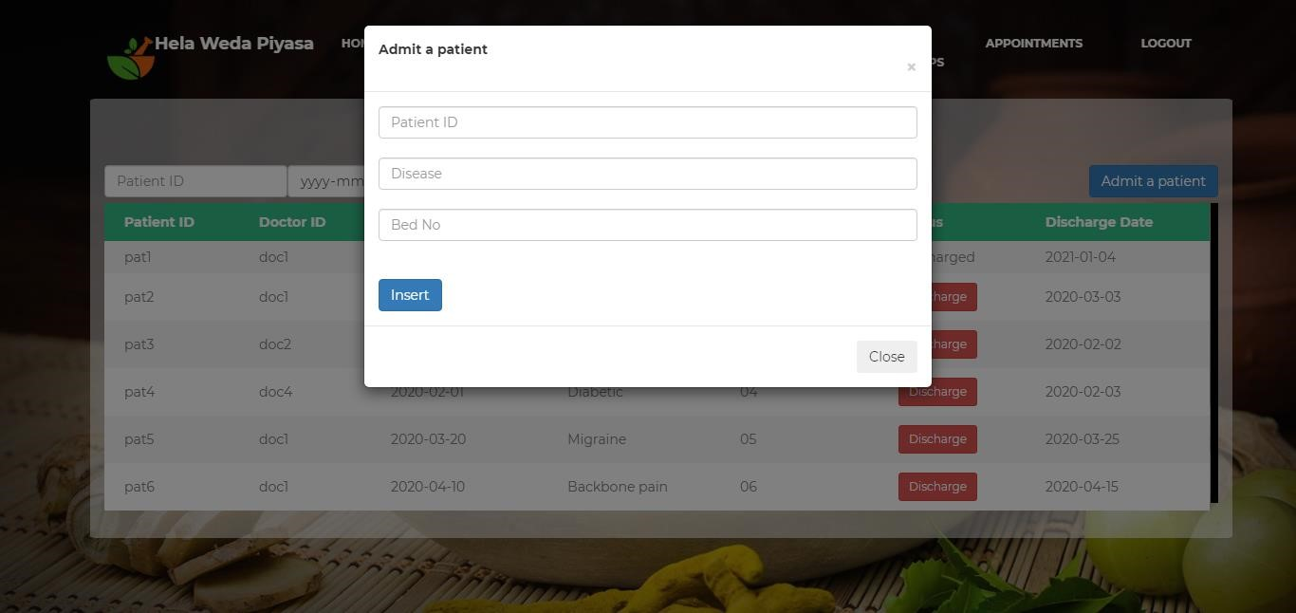

* Here the doctor should fill Patient’s ID, Disease, Bed No and Discharge Date.
* If he inserts all data, it will show a message, “**Patient** **admitted** **successfully**”
* If he fails to fill, it will show an error message, “**The** **patient** **doesn’t** **exit**”
* If he searches valid patient’s ID or date, the table will show the relevant details.
  + If he searches invalid patient’s ID or date, the table will show a message, “**No** **Patients** **Found**”

### **Admitted Patients**

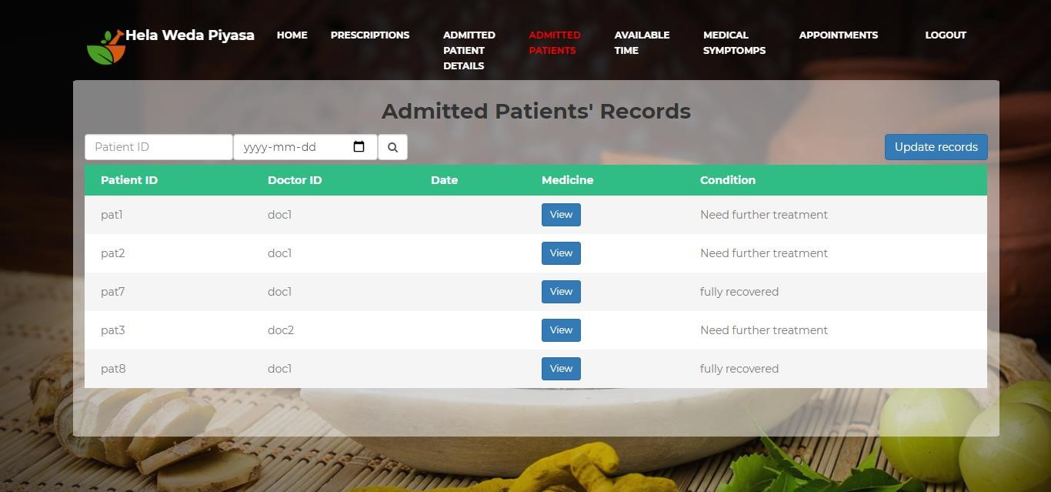

* It contains all the information of a patient on a daily basis from the time doctor is hospitalized until he recovers. Each day the doctor rounds the ward and then adds the patient's diagnoses and their condition to this table
* If we click the “**Update** **records**” button, it will show a form. We can add records of patient’s on this.

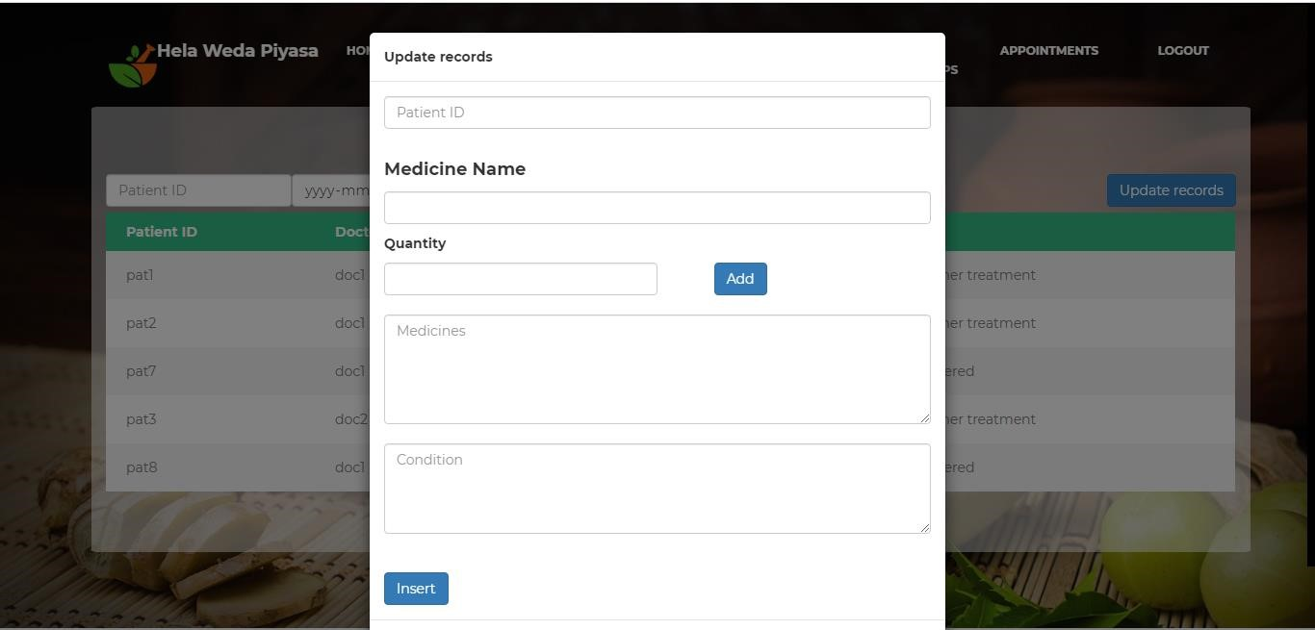

* Here the doctor should fill Patient’s ID, Medicine Name, Quantity, Medicine and Condition.
  + If he inserts all data, it will show a message, “**Inserted** **successfully**”
* If he fails to fill, it will show an error message, “**The patient doesn’t exit**”
* If he searches valid Patient’s ID or date, the table will show the relevant details.
* If he searches invalid patient’s id or date, the table will show a message, “**No records found**”

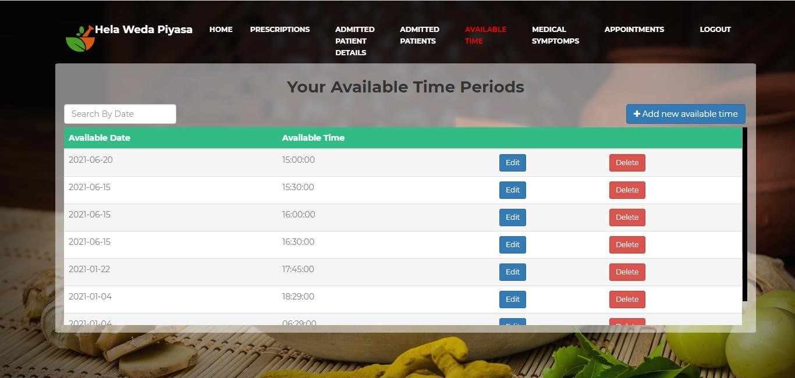

### **Available Time**

### 

* The patient should make an appointment and a date to see the doctor after enrollment in this hospital. For the convenience of the patient, the doctor will list all possible times and dates on this page. Therefore, the patient can easily make an appointment.
* On this page doctor can insert or edit or delete date and time.
* If doctor insert a new date and time, it will show a message, “**Inserted successfully**”
* If doctor click the ‘**Edit’** button, the date and time will come to the input boxes. Then doctor can edit and insert them.
* If doctor click the ‘**Delete’** button, the date and time will be deleted.
* If doctor doesn’t insert any date and time, table will show a message, “**No available times found**”
* If doctor clicks ‘**Add** **New** **Available** **Time’** button, then he can add new available date and times.

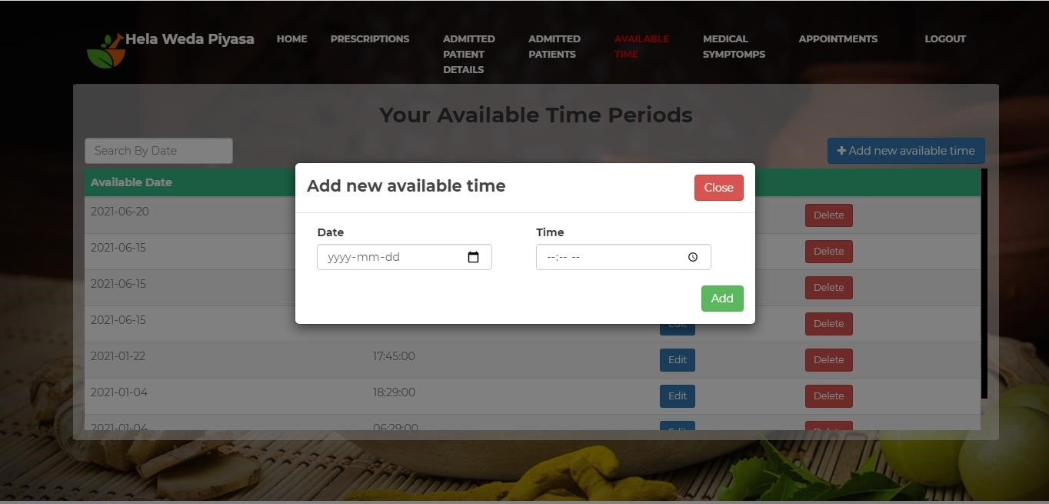

### **Medical Symptoms**

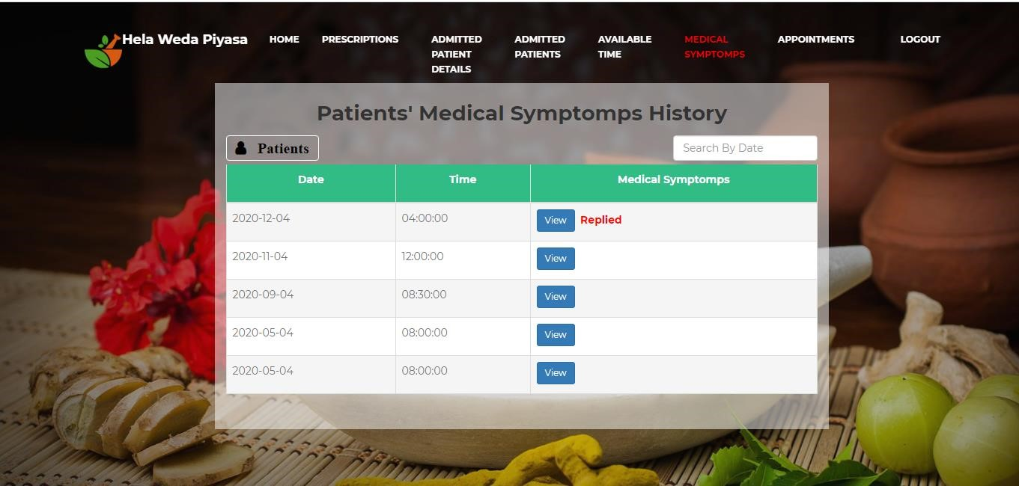

* This page illustrates the process by which an old patient or new patient informs the doctor of a brief description of the disease or a short audio clip or image if he or she is unable to visit the doctor. This makes it much easier to establish a doctor-patient interaction in the face of epidemics.
* Doctor can view patient’s medical symptoms and reply to them.
* If there is not any symptom from patients, page will show a message, “**No Any Symptoms Added Yet**”
* Here also if doctor click ‘Patients’ button, he can see patient’s details.

### **Appointments**

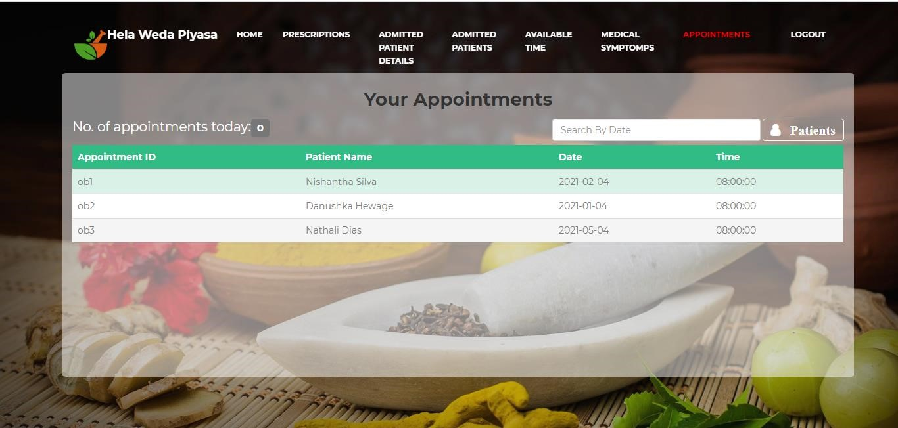

* With the busy schedule of a doctor, how much easier it would be for him to carry out his day-to-day work if he knew in advance the time allotted for him to visit their patients. So through this site we have arranged the times according to the dates booked by each patient so that the doctor can see.
* And also doctor can see number of appointments today.
* If doctor search a date and that date hasn’t any appointments from patients, the table will show a message, “**No Appointments Found**”
* Here also if doctor click ‘**Patients’** button, he can see patient’s details.

### **Patient’s UI**

The UI of patients has 5 features.

1. **Home**
2. **State Medical Symptoms**
3. **Order medicines**
4. **Online Booking**
5. **Medical History**

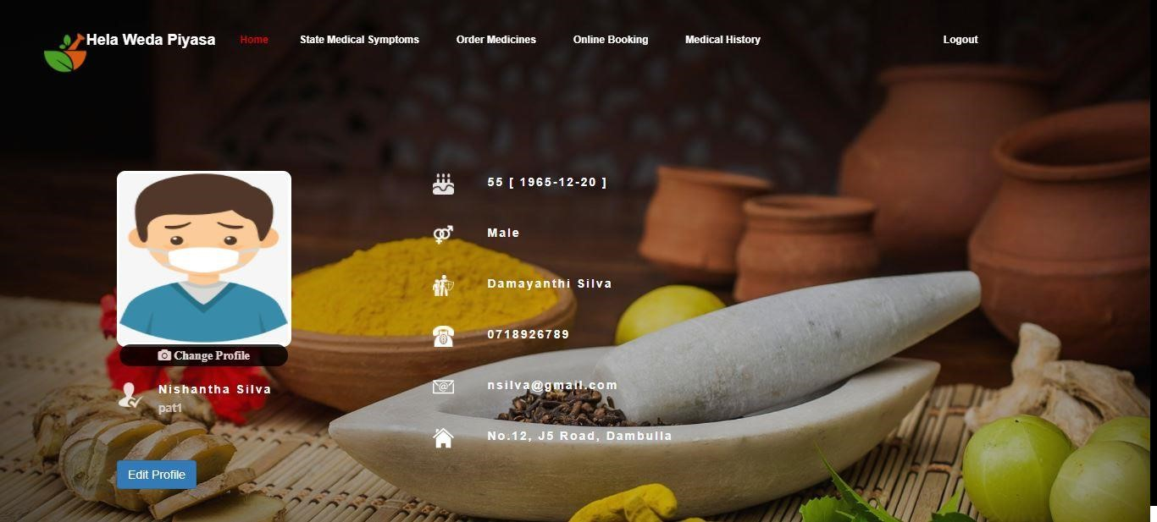

#### **Home**

* In this page the user can insert or edit his details using the ‘**Edit** **Profile’** button. He can also change the profile picture.
* If user clicks the ‘Edit Profile’ button, it will show a form. He can add or update his details on this.

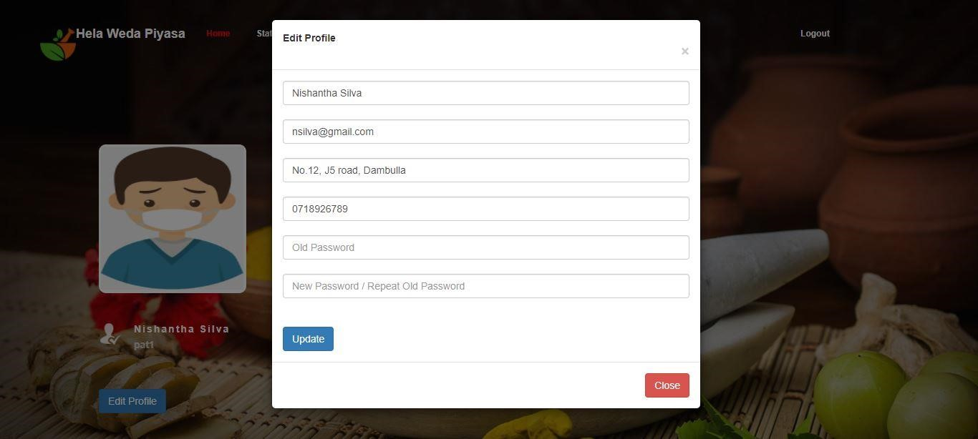

* In this form user should fill patient’s name, address, phone number, old password and new password. He can avoid email to fill the form.
* If he fails to fill, it will show an error message.
  + E.g. “Address is empty.”, “New Password is empty.”
* If the old password is wrong it’ll show, “**Password is wrong.”**
  + The new password should have at least in 6 characters. If it is not, it’ll show an error message, **“The new password must be at least 6 characters.”**
* User can change the profile picture also using ‘Change Profile’ button. It is a hidden button, so it’ll be visible when user points the cursor on the profile picture. When he clicks on it, this interface will be visible.
  + If he fails to choose any images, it will show an error message, **“You have not chosen any file.”**

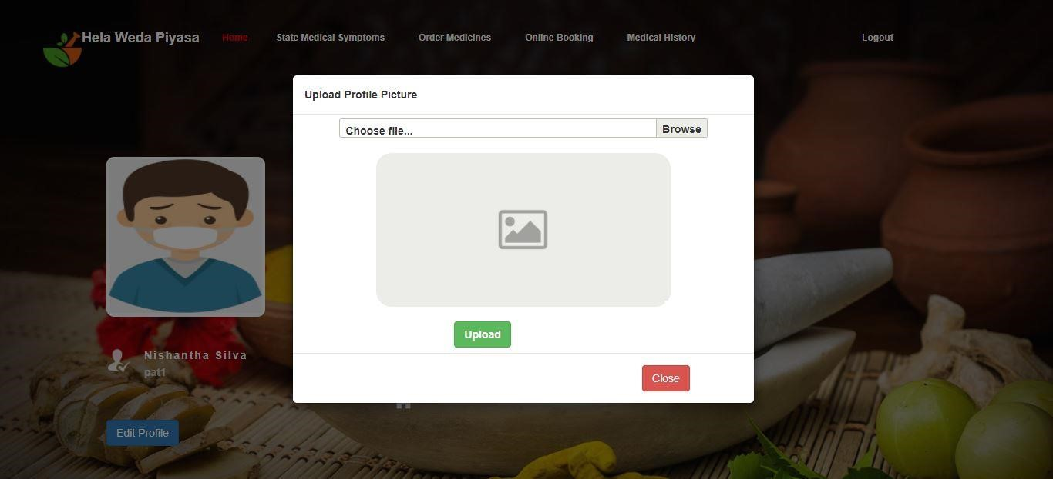

#### **State Medical Symptoms**

* This page is used to send patient’s health issues/medical symptoms to a particular doctor.

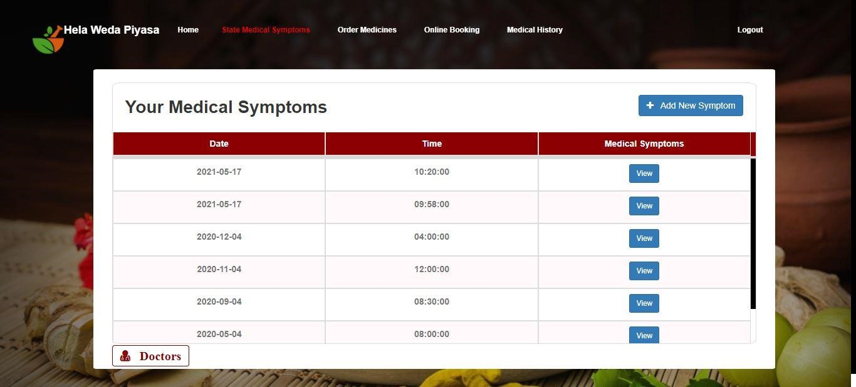

* This form will visible, when user clicks on the **‘Add New Symptom’** button

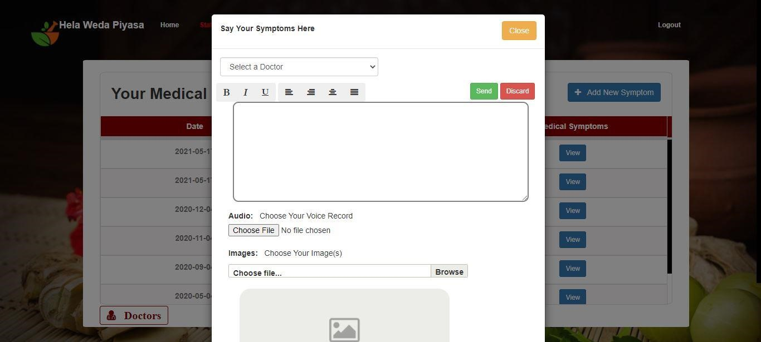

* By using scroll down button user can select a particular doctor using doctor’s name and id.
* User can type patient’s health issues on the text box. He can also insert his voice record and also add the images of the health condition.
* By click on ‘Send’ button, all the health information will send to the doctor.
* If user fails to select the doctor on this form and click ‘**Send’** button, it will show an error message “**Select** **a** **Doctor**”.
* The table has the past information with date and time that user has sent.
* When click on the view button, it will show all the details that user has sent on that day and time and also the reply of the doctor.

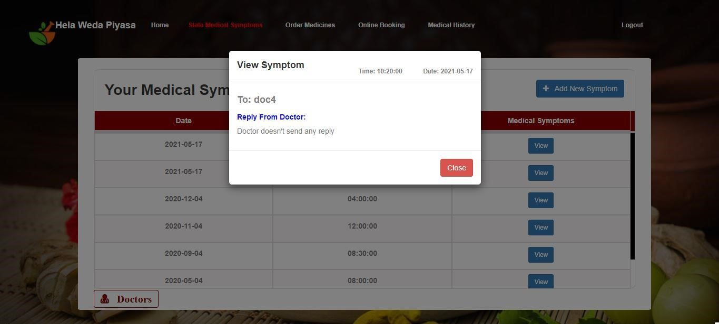

* The user can see the doctors’ details by using the ‘Doctors’ button. When click on it, it will show a table.

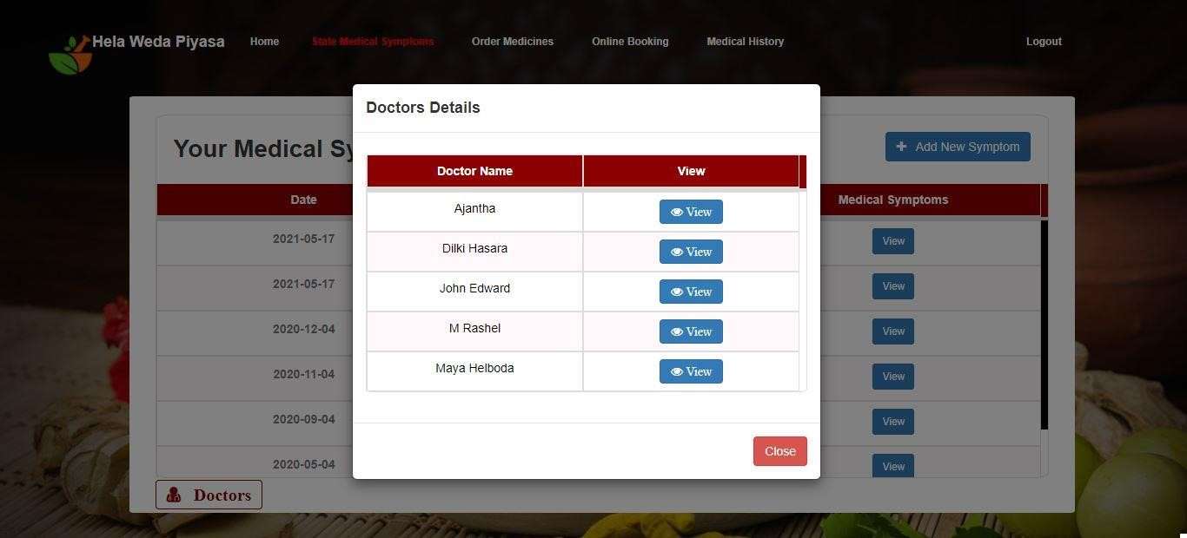

* When click on view button, it will show the doctor’s details with his photo, phone number, email and address.

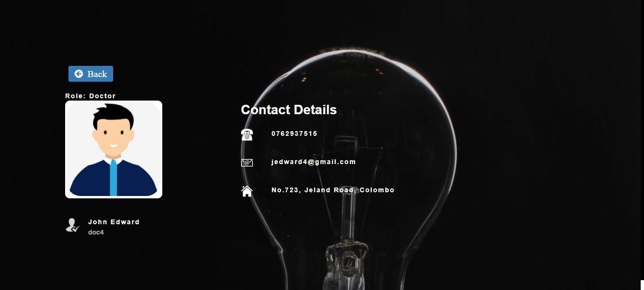

#### **Order Medicines**

* This page uses to order medicines from pharmacist in online.

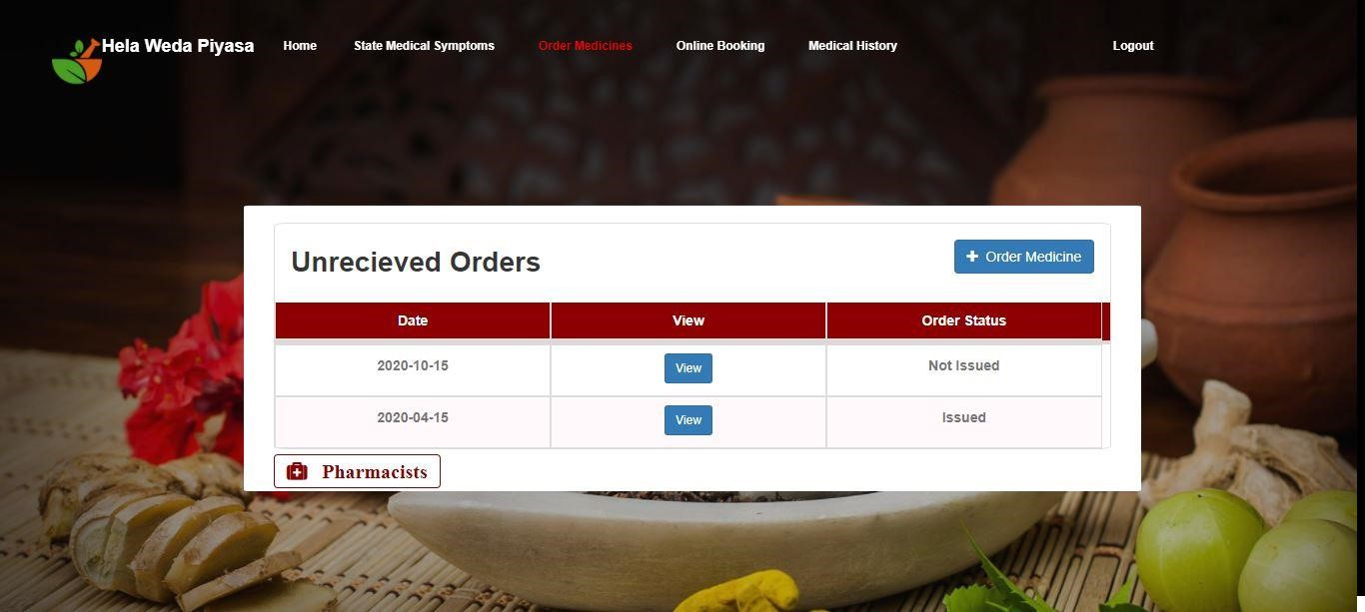

* If user clicks ‘**Order** **medicine’** button, it will show a form. He can select the medicine name and the quantity as he want and send it to pharmacist.

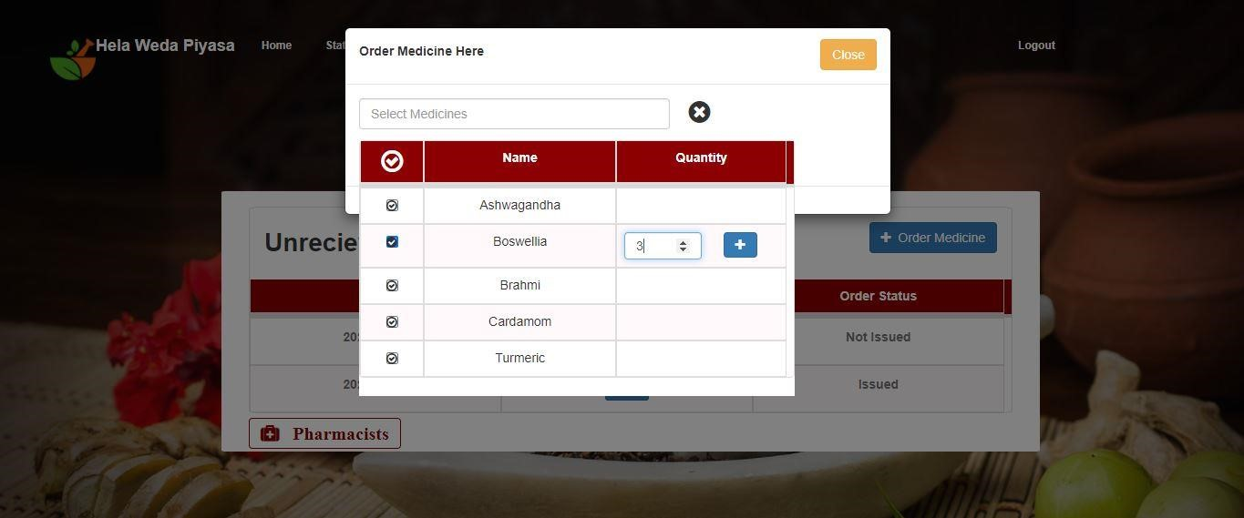

* They will receive the order and deliver the medicine to the patient’s address.
* User should select one or more medicines.
* The unreceived Orders table has the past orders those are not received yet by the pharmacist.
* The view button shows the medicines and total amount of bill.

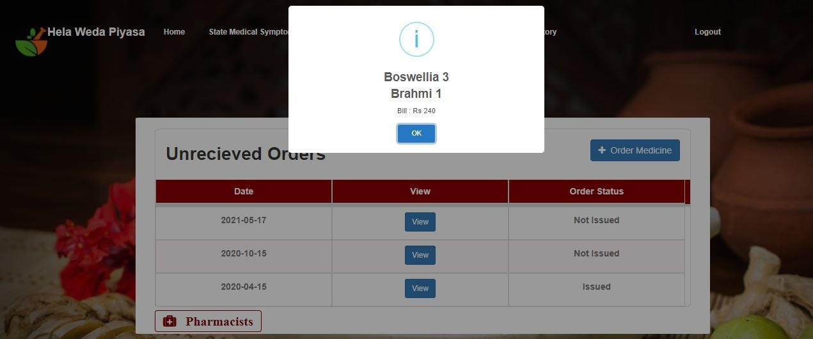

* The user can also see the pharmacist’s details by click on the ‘pharmacists’ button.

#### **Online Booking**

* In this page the patient can book the doctor appointment time.

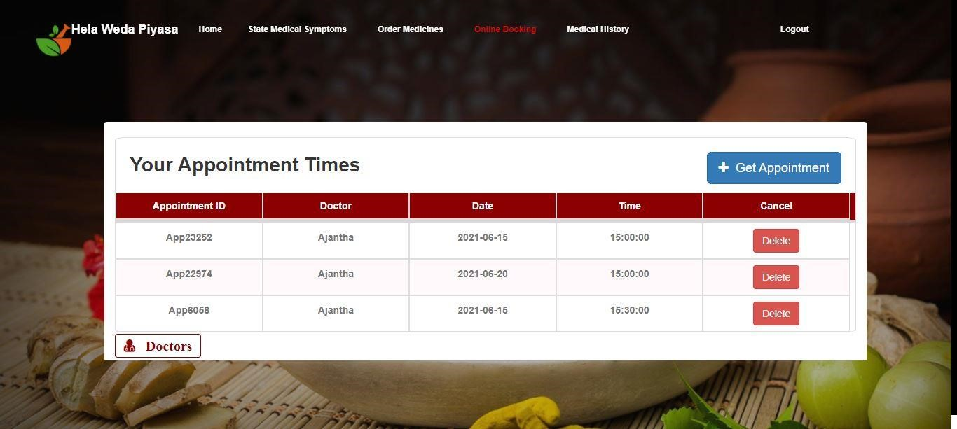

* The patient can check the doctor’s available time by click on ‘**Get** **Appointment’** button. It will show a form. There the patient can check a particular doctor’s available time on a particular date by using ‘**Search’** button.

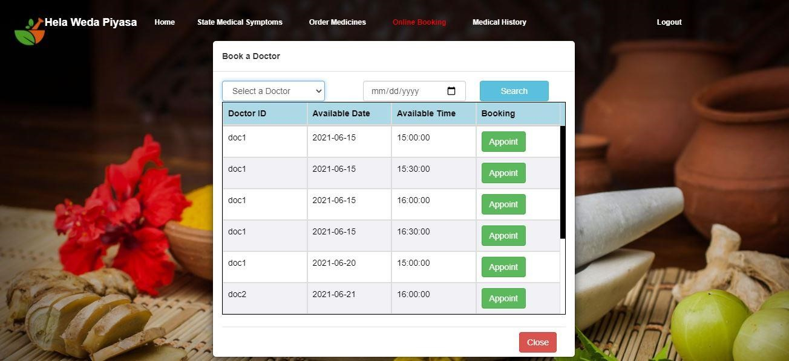

* The ‘**Appointment** **Time’** table shows all the appointment of the patient. The patient also can remove the appointment by click on ‘Delete’ button.

#### **Medical History**

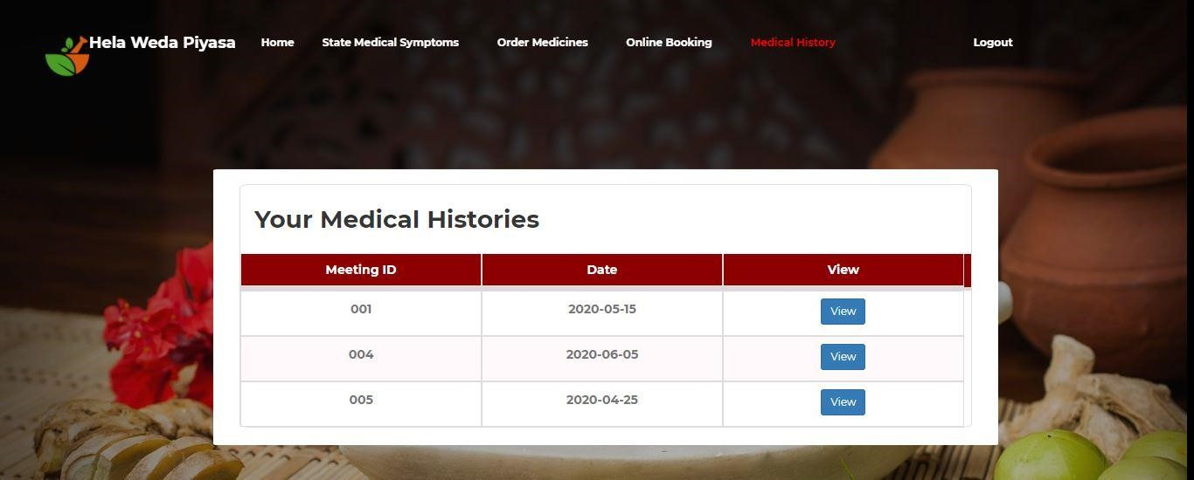

* This page shows the medical history of the patient.
* The ‘**view’** button shows the types of the disease, diagnosis and the medicines given by the doctor.

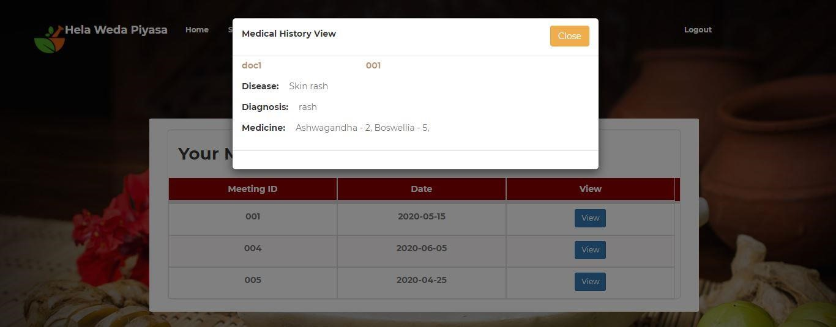

### **Pharmacist’s UI**

The UI of pharmacists has 4 features.

1. **Home**
2. [**Maintain Medical Stock**](http://127.0.0.1:8000/medicalstock/pha1)
3. [**Issue Medicine**](http://127.0.0.1:8000/issueMedicine/pha1)
4. [**Order Medicine**](http://127.0.0.1:8000/phaordermedicine/pha1)

#### **Home**



* In this page the user (pharmacist) can insert or edit his details using the ‘**Edit** **Profile’** button. He can also change the profile picture.
* If user clicks the ‘Edit Profile’ button, it will show a form. He can add or update his details on this.

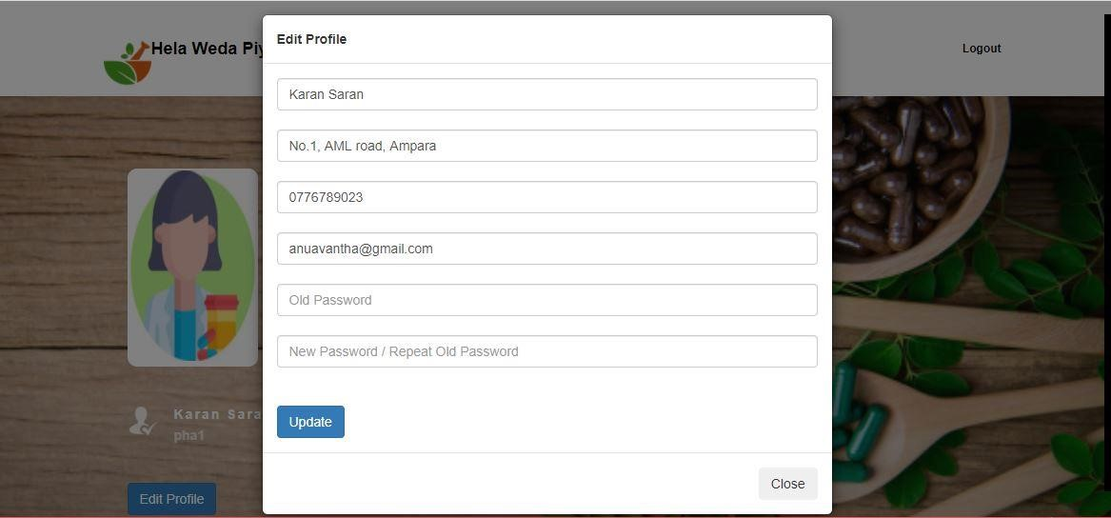

* In this form user should fill his name, address, phone number, email, old password and new password.
* If he fails to fill, it will show an error message. E.g. “**Address is empty**”, “**New Password is empty”**
* If the old password is wrong it’ll show, “**Old password is wrong**”
* User can change the profile picture also using ‘**Change Profile’** button. It is a hidden button, so it’ll be visible when user points the cursor on the profile picture. When he clicks on it, this interface will be visible.

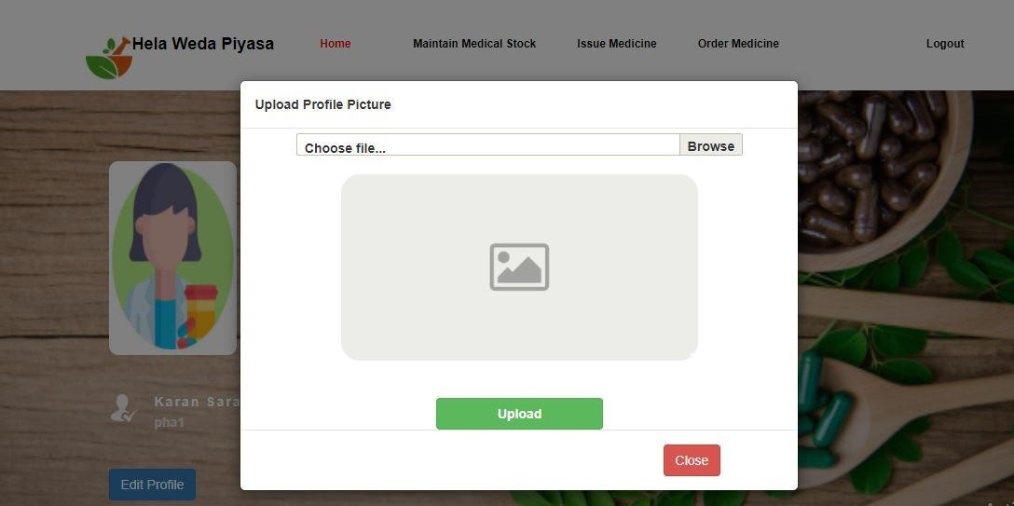

* + If he fails to choose any images, it will show an error message, “**You have not chosen any file.”**

1. [**Maintain Medical Stock**](http://127.0.0.1:8000/medicalstock/pha1)

* This page is used to maintain medical stock purposes.

.

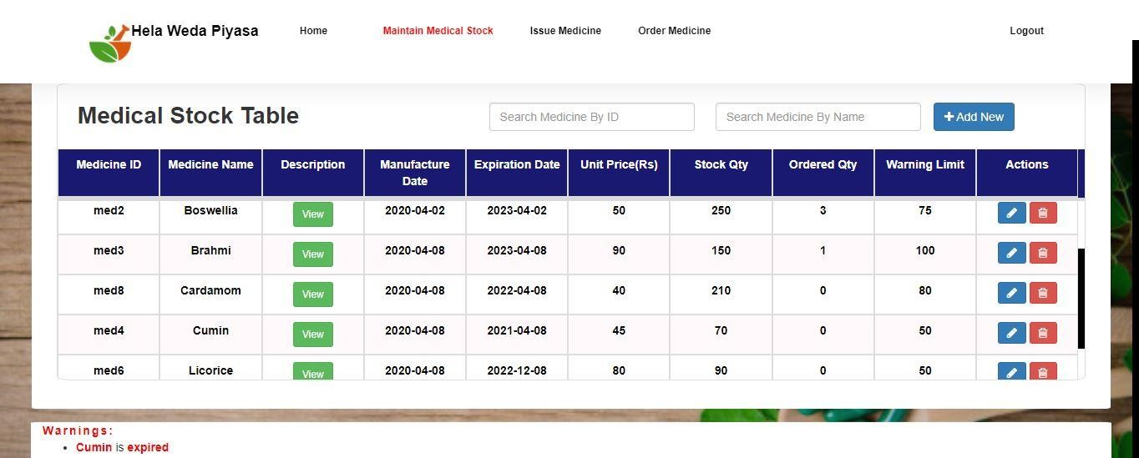

* The Medical Stock table has all types the medicines and their details (medicine id, medicine name, medicine description, manufacture date, expiration date, unit price, stock quantity, ordered quantity, warning limit - minimum no of medicines that can be in stock).
* Pharmacist can update medicine details or delete medicines from this table by using actions column. He can’t update medicine id and medicine name. If he tries to delete any medicine in the table, it will ask to conform it.

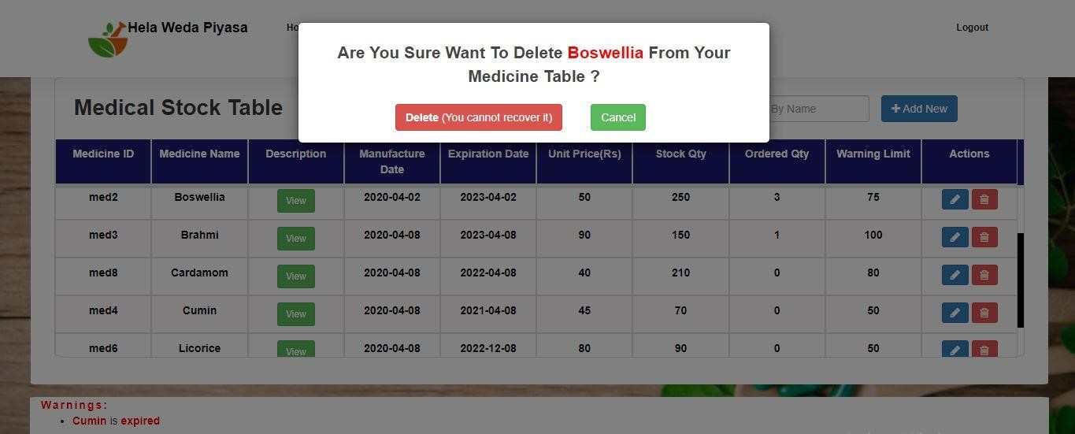

* If he fails to fill any field on the update form, it will show an error message.

E.g. set a unit price, set a quantity

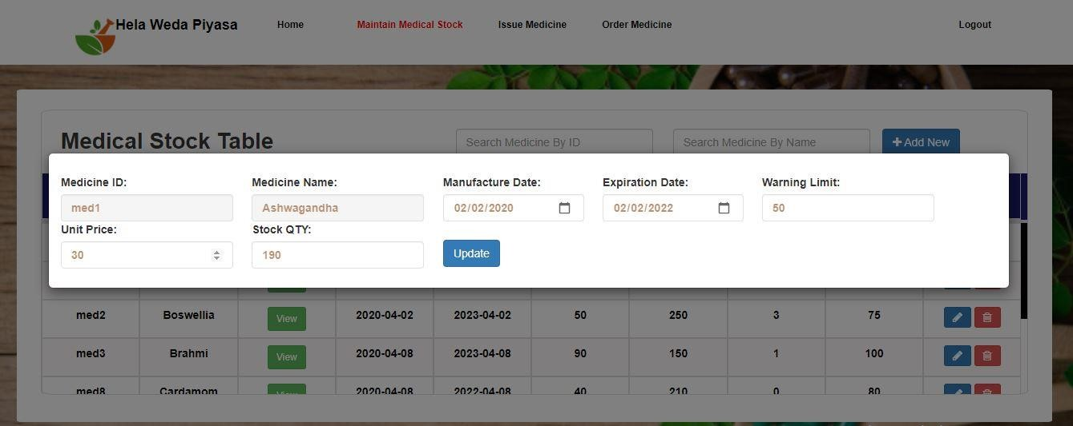

* Pharmacist can also add new medicines by using ‘**Add New’** button. It will show a form.

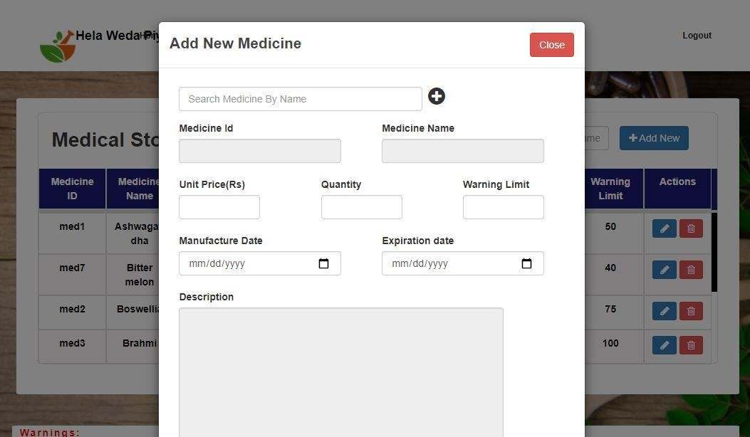

* If he tries to add medicines that are already in the table, it will show an error message.
  + E.g. Brahmi is already in your stock
* If he fails to fill any field on this form it’ll show an error message.
  + E.g. Set a unit price
* Below the table, there is a space to show warnings about the medical stock. If any medicine is expired or any medicine’s stock quantity is less than its warning limit, it will show warning messages. E.g.
  + Cumin is expired o Ashwagandha's stock quantity is 13

1. [**Issue Medicine**](http://127.0.0.1:8000/issueMedicine/pha1)

* This page is used to view patient's medicine orders and doctor's prescription by click on ‘**View’** button.

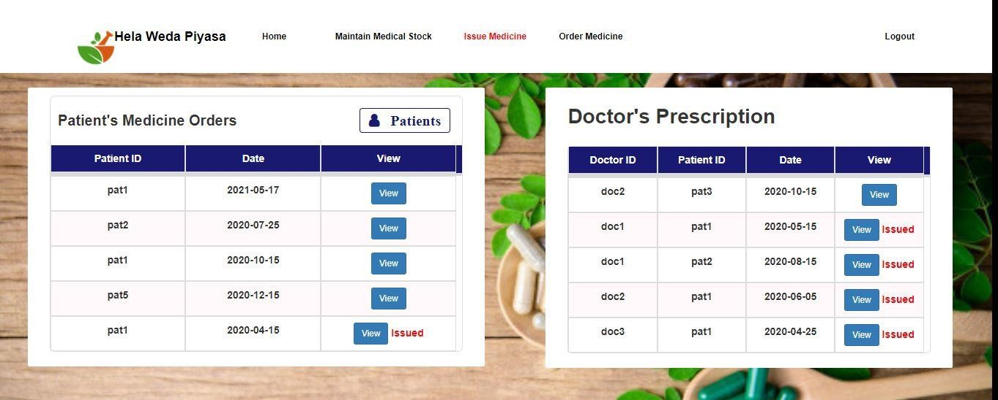

* The pharmacist can view the orders and also issue the medicine. After they issue them, pharmacist can change the orders as issued.

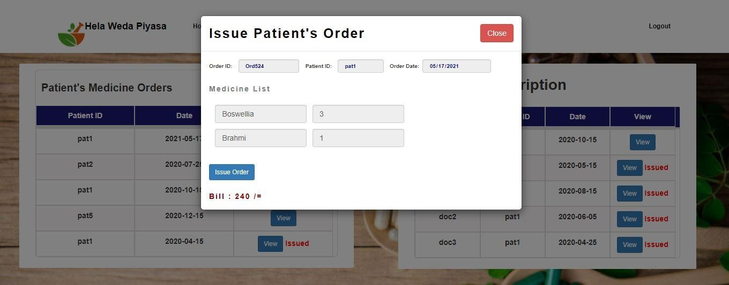

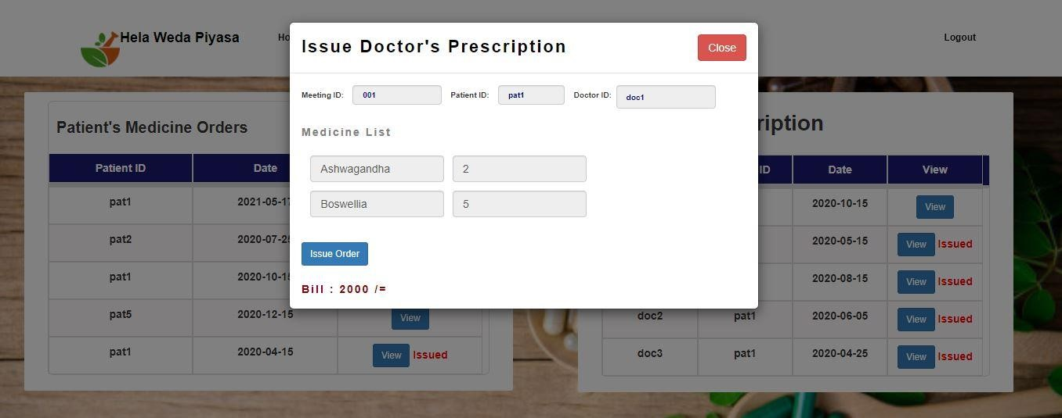

* For issue the medicines, pharmacist can view all the patient’s details using ‘**Patients’** button.

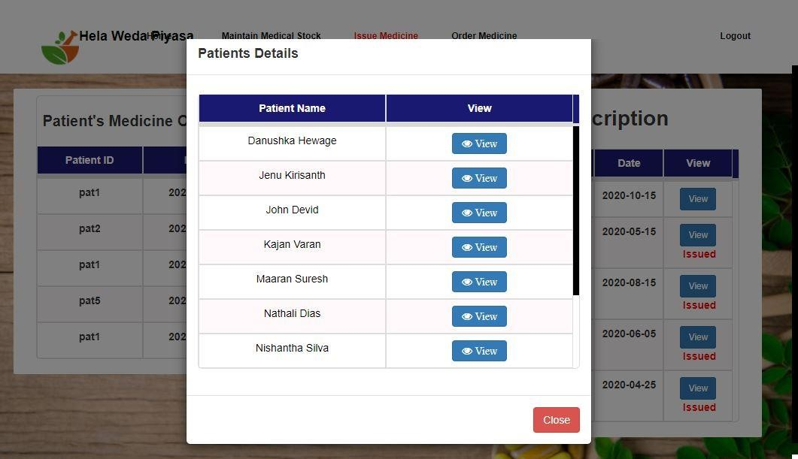

* The **view** button shows the patient’s details.



1. [**Order Medicine**](http://127.0.0.1:8000/phaordermedicine/pha1)

* This page is used to order medicines from medicine producers.

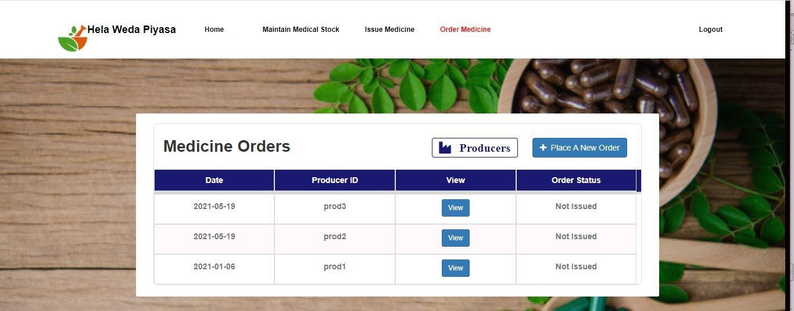

* ‘**Place A New Order**’ button is used to order medicines. It will show this form.

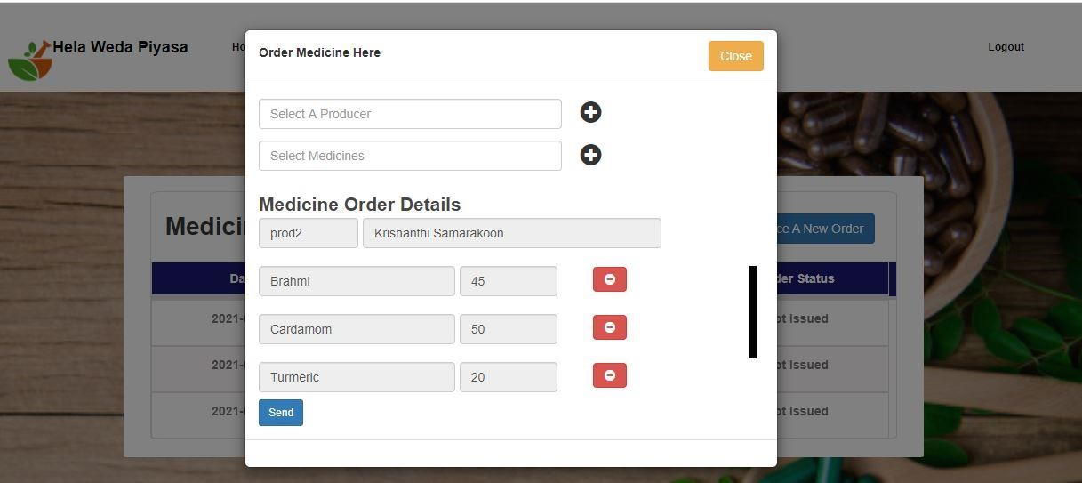

* The medicine orders table has the order history with date, producer id and order details.
* The ‘Order Status’ column shows that the order is issued or not.
* Pharmacist can view the producer’s details using ‘Producers’ button.

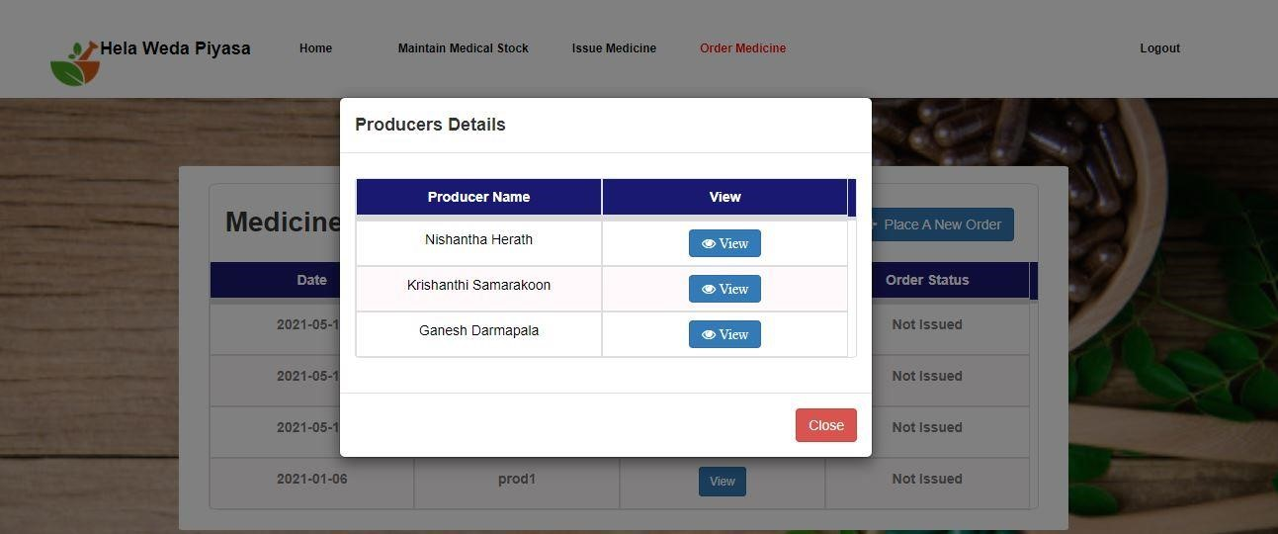

* The **view** button shows the producer’s details.

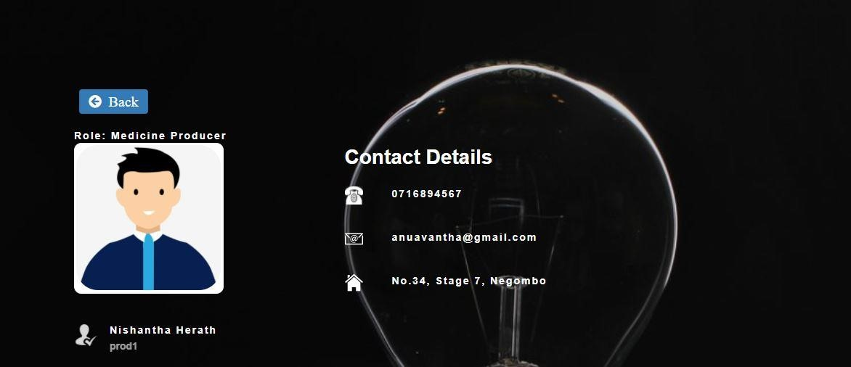

### **Medicine Producer’s UI**

The UI of Medicine Producer has 6 features.

1. **Home**
2. **Issue Medicines**
3. **Ingredients Stock**
4. **Medicine Stock**
5. **Order Ingredients**
6. **Medicine**

#### **Home**

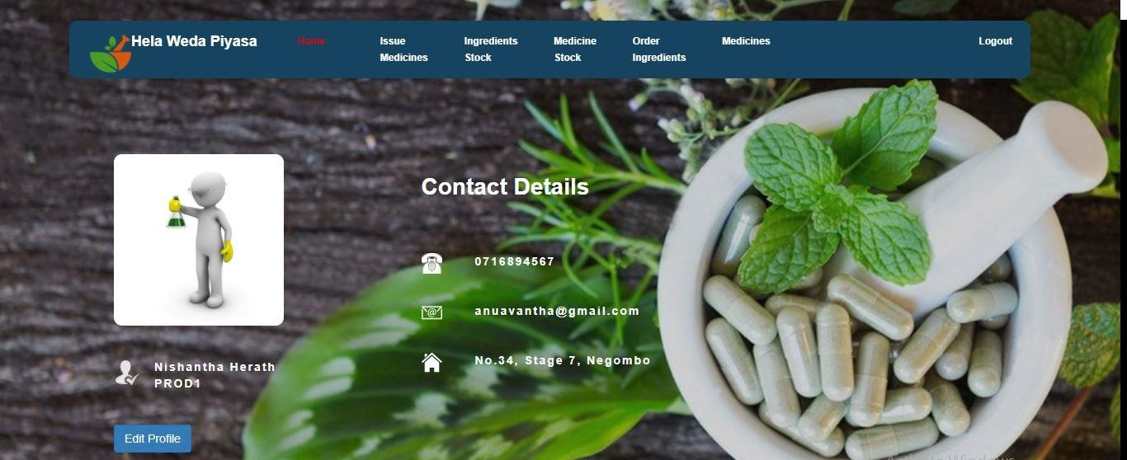

* In this page the producer can insert or edit his/her details using the ‘**Edit** **Profile’** button. And he can add/change the profile picture.

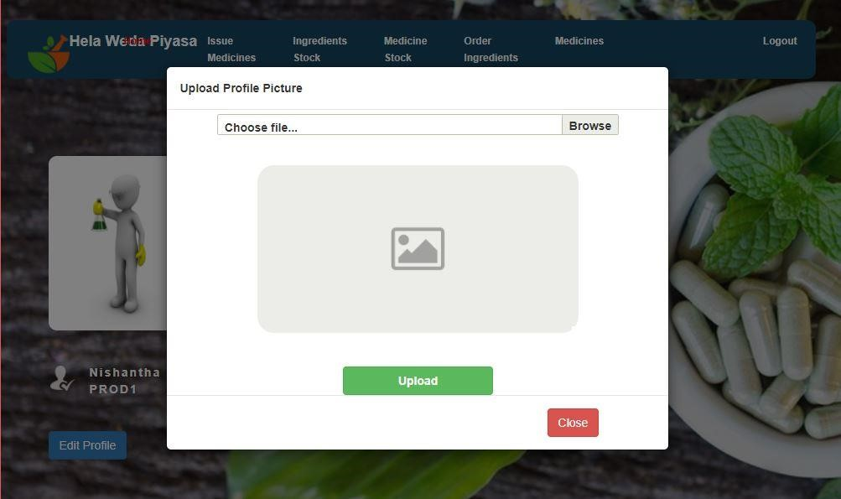

* If he clicks the ‘**Edit Profile’** button, it will show a form. We can add or update our details on this.

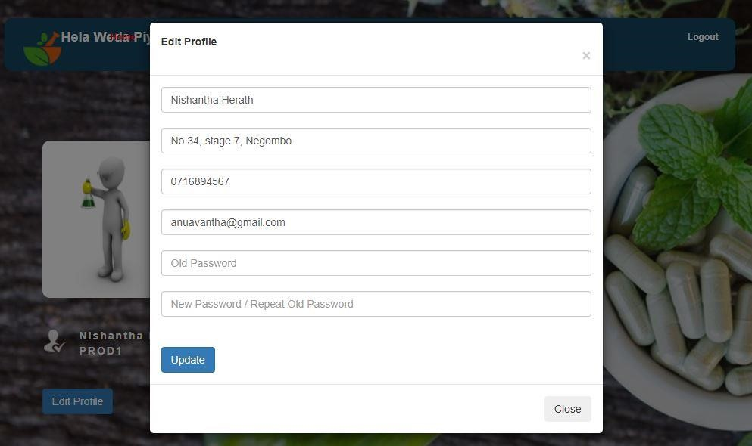

* Here the producer should fill user’s name, address, phone number, old password and new password. He can avoid email to fill the form.
* If he fills it with valid data, it will show a message. o “Updated successfully”
* If he fails to fill, it will show an error message. o E.g. “Address is empty”, “New Password is empty”
* If the old password is wrong it will show, o “Password is wrong”

#### **Issue Medicines**

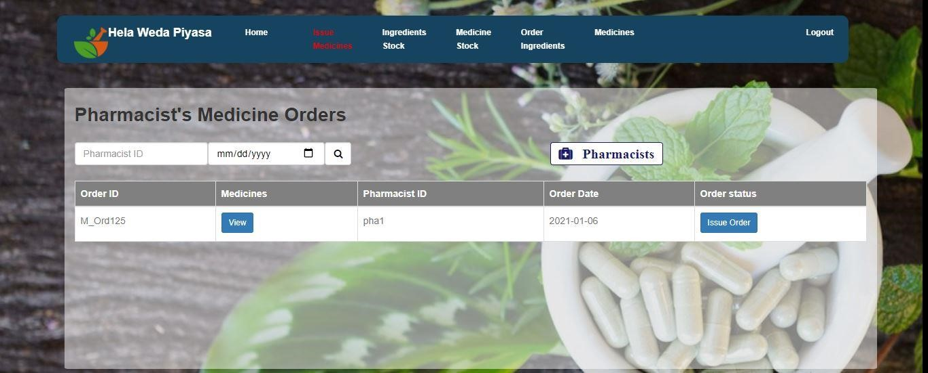

* Here producer can see all details of issued medicines, and pharmacist's medicine orders.
* He can search pharmacist's orders and issued date of the medicines by their ID.

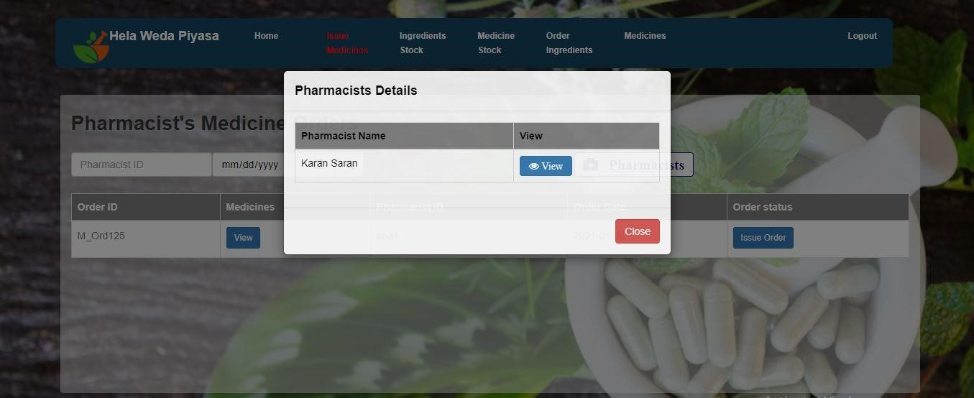

* If producer give a valid name, it will view the details of issued and ordered medicines.

#### **Ingredients stock**

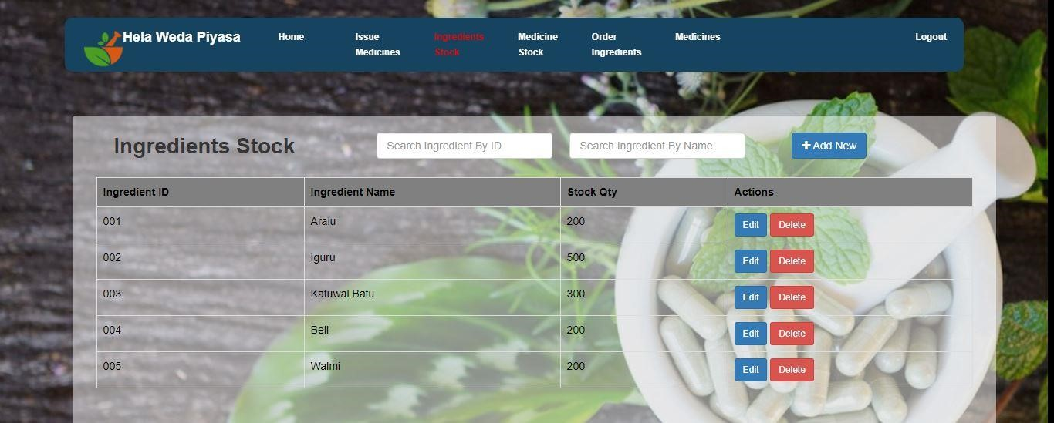

* On this page pharmacist can see the ingredients stocks.
* Such as ingredient ID, name, stock quantities.
* If pharmacist give a valid ingredient ID or name it will show the name and quantity of that ingredient.

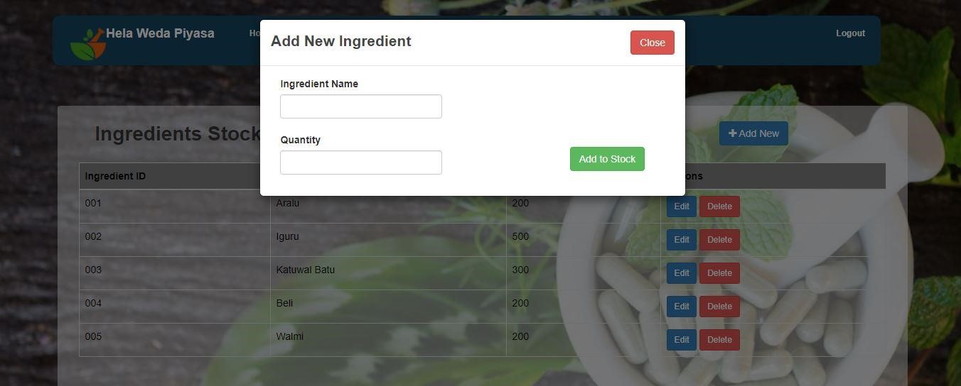

* And can edit and delete these details.
* If an ingredient is over then it will be deleted.
* If an ingredient will be got then the quantity will be edited.
* If a new ingredient is introduced then it can also add here.

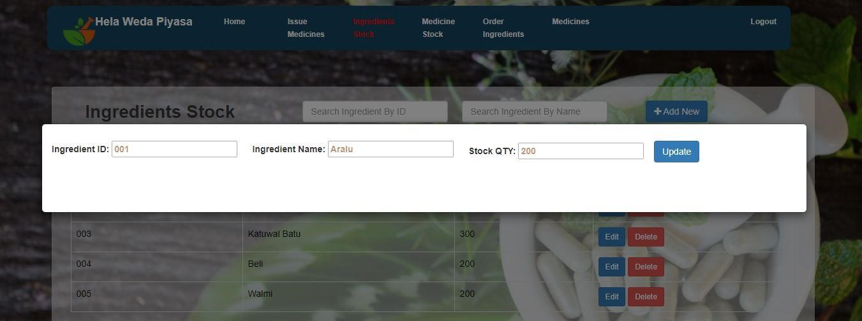

* If he gives new ingredients ID, name and quantity it will be updated.

#### **Medicine Stock**

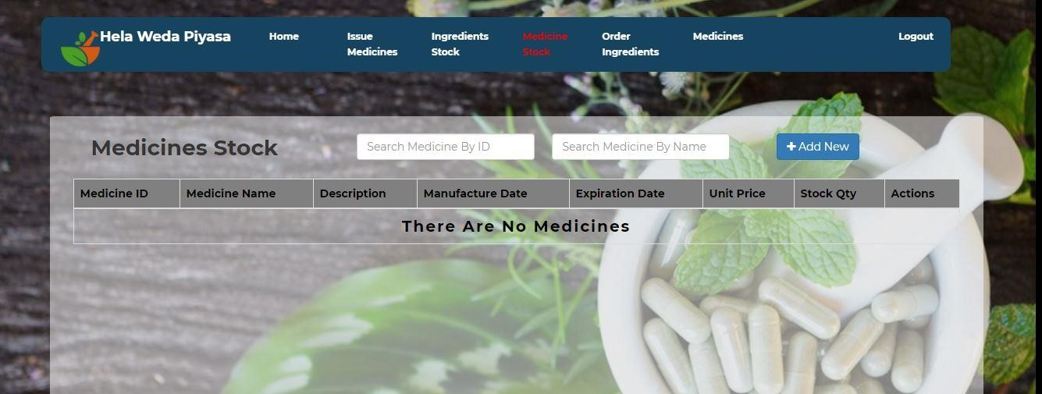

* Here pharmacist can see stock of medicines and their quantity.
* Here pharmacist can add a new medicine.
* If he provide valid medicine name, price per unit, quantity, manufactured date and expiry date, it will be added.

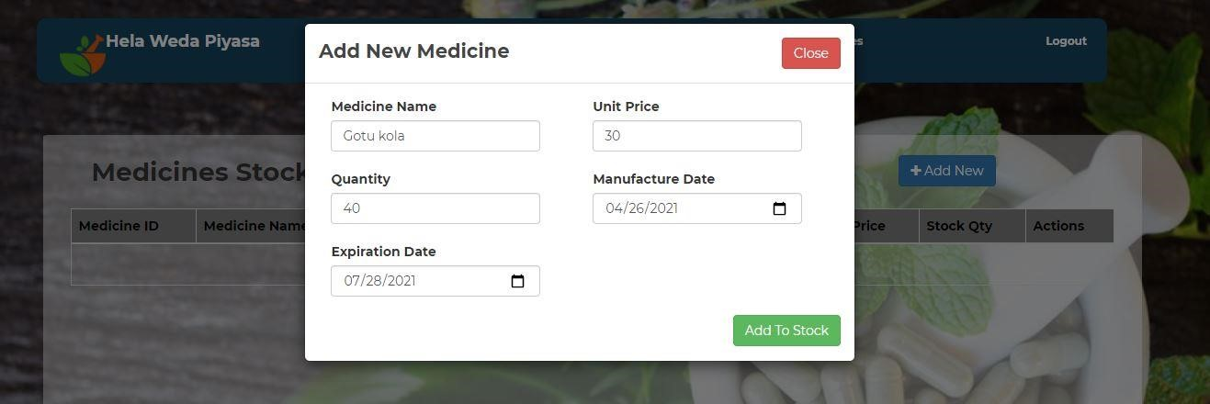

* Then he can search it by ID or name.

#### **Order Ingredients**

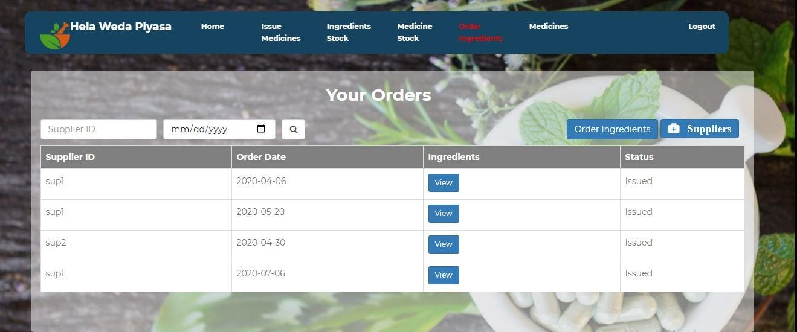

* If the pharmacist click on the box of order ingredient, it will show ordered ingredients details and he can see suppliers and corresponding orders.

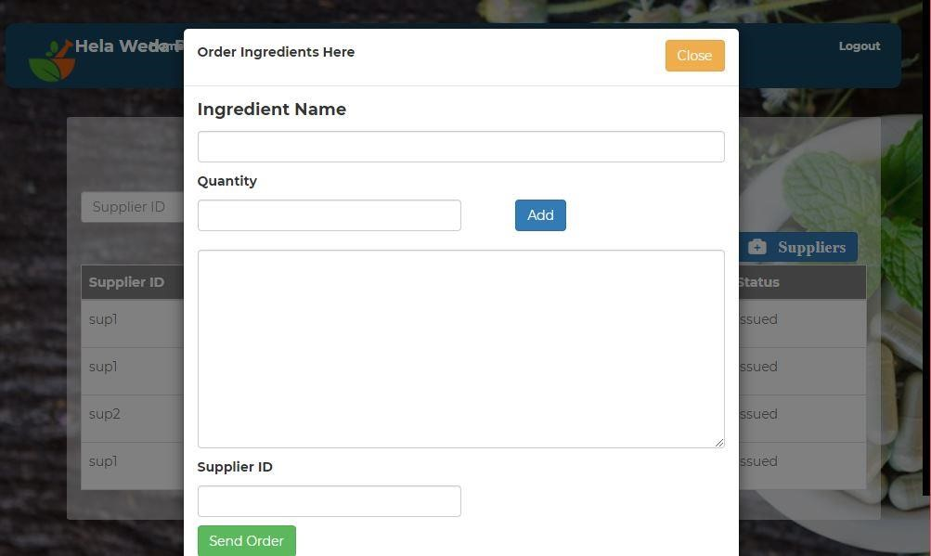

* And he can search ingredient ordered date, an ingredient is ordered or not and it will be issued or not by the supplier ID.

#### **Medicine**

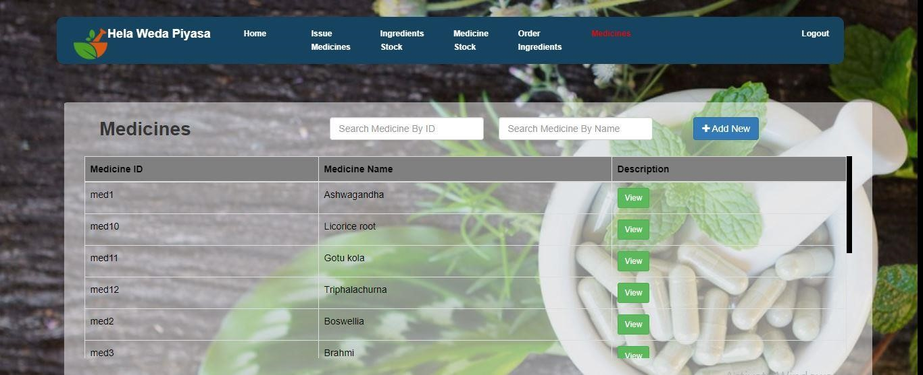

* Here producer can see the all details of medicine such as Med ID, medicine name and descriptions.
* He can search any medicine by its ID or name.

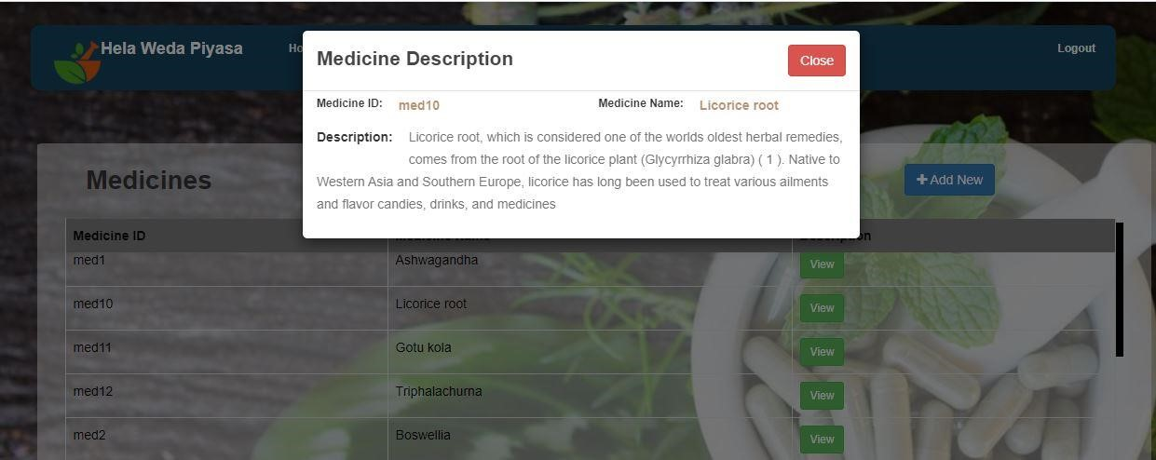

* If he gives medicine Id or medicine name, it will show descriptions of medicine.
* And he can add new medicines.
* If he adds a valid medicine name and description then it will show a message as new medicine has added.

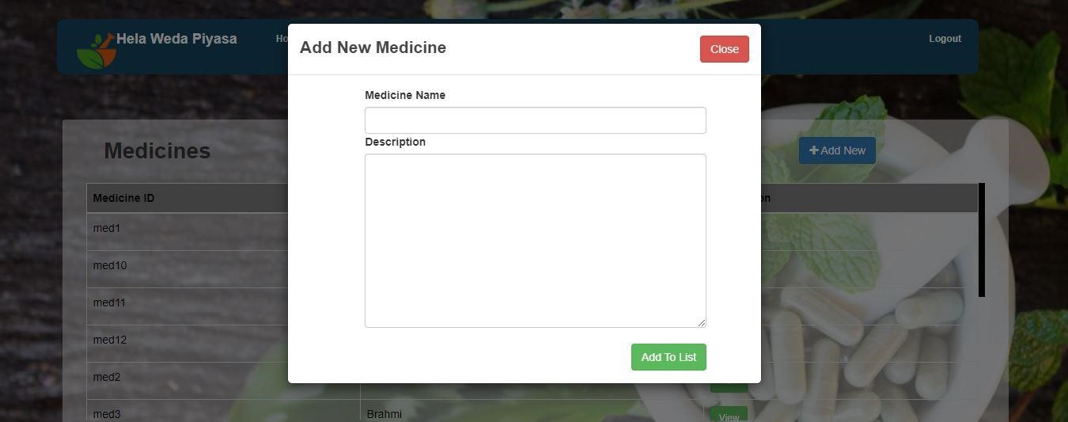

* After his works finished, he can logout and leave the current page.

### **Ingredients Supplier’s UI**

The UI of Ingredients Supplier has 3 features.

1. **Home**
2. **Ingredients Ordering**
3. **Ingredients**

#### **Home**

* If we click the home button it will show the supplier's contact details.

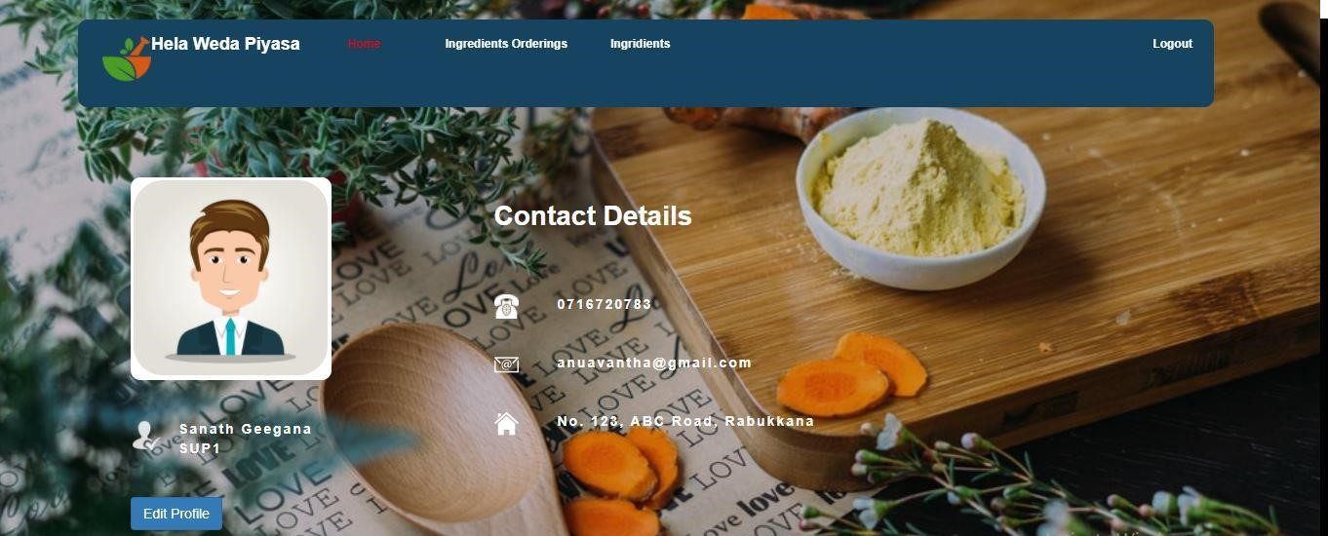

* Here supplier can change his profile.

#### **Ingredients Ordering**

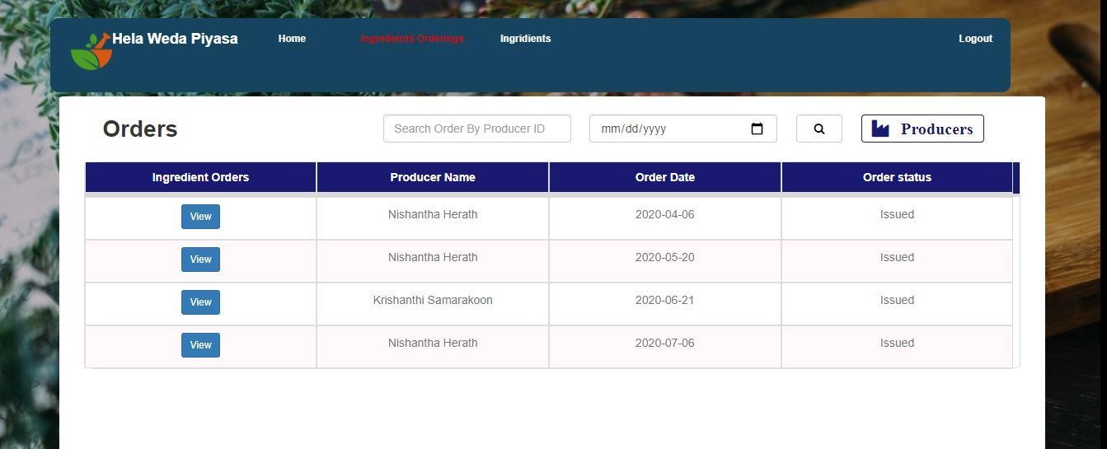

* If he clicks on it, it shows all details of orders such as ingredient orders, producer names, order dates and order status.
* Here he can search order ingredients by producer's ID. He can view ingredient orders too. And he can see the specific order is issued or not.

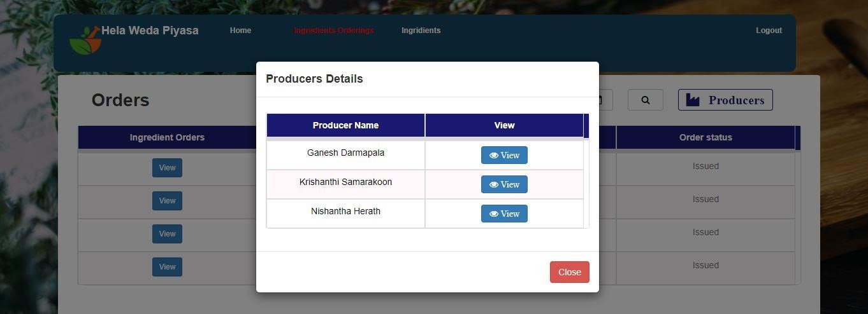

#### **Ingredients**

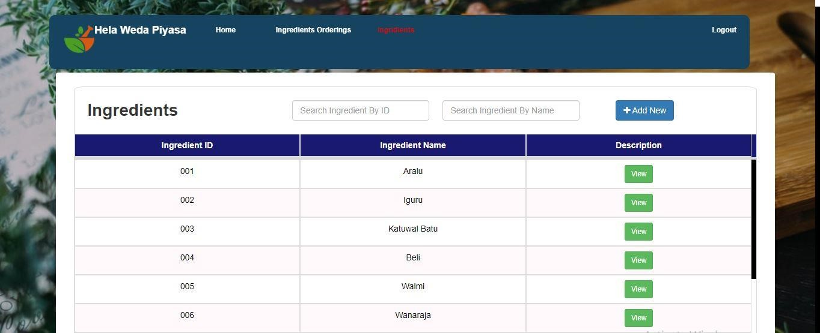

* If he clicks on it, it will show all details of ingredients.
* He can search specific ingredient by its ID and it can view the description.